A
PROJECT
REPORT ON
“B-3 SENSOR BASED STREET LIGHTS”
Submitted in Partial Fulfillment of requirements For the award of the degree of
DIPLOMA IN ELECTRICAL ELECTRONIC ENGINEERING OF STATE BOARD OF TECHNICAL EDUCATION AND TRAINING SUBMITTED BY
I.NARASIMHA 22239-EC-041
D.MAHENDAR 22239-EC-021
Y.ABHISHEK 22239-EC-034
B.PAVANI 22239-EC-048
SK.SHAHIN 22239-EC-013

Under the Esteemed Guidance of
Mr.C.PURNAPAKASH, M.Tech

DEPARTMENT OF ELECTRONICS AND COMMUNICATION ENGINEERING
BOMMA INSTITUTE OF TECHNOLOGY AND SCIENCE (Approved by SBTET,TELANGANA) Allipuram, Khammam-507318.

BOMMA INSTITUTE OF TECHNOLOGY AND SCIENCE-POLYTECHNIC
(Approved by SBTET,TELANGANA) Allipuram, Khammam-507318.

CERTIFICATE
This is to certify that the Dissertation entitled “B-3 SENSOR BASED STREET LIGHTS” is a bonafied work done by
I.NARASIMHA 22239-EC-041
D.MAHENDAR 22239-EC-021
Y.ABHISHEK 22239-EC-034
B.PAVANI 22239-EC-048
SK.SHAHIN 22239-EC-013
in partial fulfillment of the academic requirements for the award of the degree of Diploma in Electronics and communication Engineering, Bomma Institute of Technology And Science, Allipuram, Khammam during the period 2024.

Internal Guide Head of the Dept.
Mr.C.PURNAPRAKASH M.Tech Mr.K.RAJU M.Tech Associate Professor
Principal
Mr.B.M. RANJITH M.Tech PhD

ACKNOWLEDGEMENT
I would like to thank God and my parents for giving more support for me in Completing this project.
I am grateful to Mr.C.PURNAPRAKASH M.Tech For his valuable suggestions and guidance given by him during the execution of this project work.
I would like to thank Mr.K.RAJU M.Tech Head of the Department of Electronics & Communication Engineering, for being moral support throughout the period of my study in BITS.
Iam highly indebted to Principal Prof. Mr.B.M. RANJITH M.Tech PhD. for giving me the permission to carry out this project
I render my thanks to Sri BOMMA RAJESWARA RAO garu, Chairman
Bomma group of institutions, for his encouragement.
I would like to thank the Teaching & Non- teaching staff of Department of
Electronics & Communication Engineering for sharing their knowledge with me.
I express my thankfulness to all the people who have helped me directly or indirectly in the completion of academic major project.
I.NARASIMHA 22239-EC-041
D.MAHENDAR 22239-EC-021
Y.ABHISHEK 22239-EC-034
B.PAVANI 22239-EC-048
SK.SHAHIN 22239-EC-013

DECLARATION
I declare that industrial training is reported and presented the record of work done by
the “B-3 SENSOR BASED STREET LIGHTS”
No part of these is copied from books, journals, internet and wherever the portion is taken the same has been fully referred in text.
The report is based on the work done entirely by us and not copy from any source.

Yours sincerely
I.NARASIMHA 22239-EC-041
D.MAHENDAR 22239-EC-021
Y.ABHISHEK 22239-EC-034
B.PAVANI 22239-EC-048
SK.SHAHIN 22239-EC-013

CONTENTS

Chapter-I: INTRODUCTION
1.1 Introduction
1.2 Abstract
1.3 Block Diagram proposal for the system

CHAPTER2. DESCRIPTION OF HARDWARE COMPONENTS
2.1 AT89S52
2.1.1 Introduction to AT89S52
2.1.2 Features
2.1.3 Architectural overview
2.1.4 Pin description for AT89S52
2.1.5 Memories

2.2 Power Supply
2.3 LCD
2.4 PIR SENSOR
2.5 LDR
2.6 ULN2003
2.7 LED STRRET LIGHT

Chapter-III: CIRCUIT DIAGRAM
3.1. Circuit Diagram
3.2 Source code

Chapter-IV: OUTPUT RESULTS
4.1. Output results

Chapter-V: KEIL SOFTWARE DEVELOPMENT
5.1. Introduction
5.2. Tools used
5.3 C51 compiler
5.4 Start U vision

5.5 Overview of Keil u vision

Chapter-VI: PROTEUS DESIGN
6.1. Proteus Introduction
6.2. Creating a new Project
6.3 Cursor description
6.4 Design Overview
6.5 Selecting parts from Library
6.6 Part label and annotation

Chapter-VII: CONCLUSION

CHAPTER-I
INTRODUCTION

Introduction

- Project Introduction: B-3 Sensor Based Street Light
The B-3 Sensor-Based Street Light is an innovative project designed to optimize street lighting in urban and rural environments. By incorporating advanced sensors, this system aims to enhance energy efficiency, reduce operational costs, and improve public safety. The primary objective of this system is to automatically adjust the brightness of streetlights based on real-time environmental factors, such as pedestrian movement, ambient light, and weather conditions.

- Key Features:
1.B-3 Sensor Integration: The B-3 sensor will detect motion and ambient light levels, enabling the streetlight to automatically turn on when it detects movement or when ambient light drops below a certain threshold, such as during the evening or at night.
2.Energy Efficiency: By using the B-3 sensor to dim or brighten streetlights based on real-time requirements, the system reduces unnecessary power consumption during low traffic periods, such as late at night when fewer people are on the streets.
3.Improved Safety: The sensor ensures that lights are on when there is movement around, providing a safer environment for pedestrians and drivers, especially in isolated areas where low visibility could lead to accidents or crimes.
4.Cost-Effective: With dynamic lighting control, the need for manual intervention in managing streetlights is minimized, reducing both maintenance costs and the overall electricity bill for cities and municipalities.
5. Environmental Impact: The system helps in reducing the carbon footprint of street lighting, contributing to a more sustainable urban environment.

- How It Works:
1.Detection of Ambient Light: The B-3 sensor detects the amount of natural light available in the area. When natural light falls below a certain level (e.g., at dusk), the sensor triggers the streetlight to turn on.
2.Motion Detection: The sensor is also capable of detecting movement (pedestrians or vehicles). When movement is detected, the light is automatically brightened to ensure maximum visibility. After a period of inactivity, the light dims to save energy.
3.Communication System: The lights are connected to a central control system, which allows real-time monitoring and adjustments. The system can be accessed remotely for maintenance, performance analysis, or troubleshooting.

- Benefits:
1.Smart Lighting Control: Automatic adjustments based on ambient conditions and motion provide a smarter, more responsive lighting system.
2.Energy Savings: Reduces power consumption by dimming lights during low traffic periods and adjusting brightness when necessary.
3.Cost Savings: Saves on electricity and maintenance costs by minimizing the use of streetlight energy and wear and tear.
4.Sustainability: Reduces carbon emissions, contributing to environmental preservation.

The B-3 Sensor-Based Street Light is a step toward smarter, greener cities that enhance the quality of life for their residents. Through this innovation, urban areas can achieve more sustainable, safer, and cost-effective public lighting solutions.

Abstract

- Project Abstract: B-3 Sensor-Based Street Light System
The B-3 Sensor-Based Street Light System is designed to enhance the energy efficiency and safety of public lighting systems. This project integrates advanced sensor technology, specifically B-3 sensors, to detect movement and ambient light levels. The system automatically adjusts the brightness of street lights based on the presence of pedestrians or vehicles and environmental lighting conditions. When no movement is detected, the street lights dim or turn off, significantly reducing energy consumption. Conversely, when activity is detected, the lights automatically brighten, ensuring proper visibility and safety for pedestrians and motorists.

In addition to energy savings, the system promotes sustainability by extending the lifespan of the lights, reducing maintenance costs, and contributing to the reduction of carbon emissions. The project aims to offer a cost-effective and environmentally friendly alternative to traditional street lighting while improving urban safety and optimizing energy usage.

This project involves designing, implementing, and testing the B-3 sensor-based street light system, including sensor calibration, integration with microcontrollers, and software development for real-time monitoring and control. By adopting this smart street lighting solution, municipalities can achieve significant improvements in both energy management and public safety.

1.3 Block Design Proposal for the System

A
T
8
9
S
5
2
RPS
LCD

PIR
ULN2003

d
STREET LIGHT
LDR

Fig 1.1 Block Design Proposal for the System

CHAPTER-II
DESCRIPTION OF HARDWARE COMPONENTS

2.1 AT89S52
The AT89S52 is a low-power, high-performance CMOS 8-bit microcontroller with 8K bytes of in-system programmable Flash memory. The device is manufactured using Atmel’s high-density nonvolatile memory technology and is compatible with the industry-standard 80C51 instruction set and pin out. The on-chip Flash allows the program memory to be reprogrammed in-system or by a conventional nonvolatile memory pro-grammar. By combining a versatile 8-bit CPU with in-system programmable Flash on a monolithic chip, the Atmel AT89S52 is a powerful microcontroller, which provides a highly flexible and cost-effective solution to many, embedded control applications.
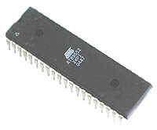
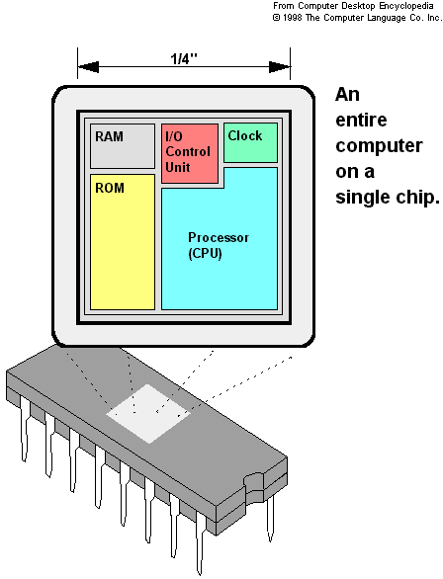
The AT89S52 provides the following standard features: 8K bytes of Flash, 256 bytes of RAM, 32 I/O lines, Watchdog timer, two data pointers, three 16-bit timer/counters, a six-vector two-level interrupt architecture, a full duplex serial port, on-chip oscillator, and clock circuitry. In addition, the AT89S52 is designed with static logic for operation down to zero frequency and supports two software selectable power saving modes. The Idle Mode stops the CPU while allowing the RAM, timer/counters, serial port, and interrupt system to continue functioning. The Power-down mode saves the RAM con-tents but freezes the oscillator, disabling all other chip functions until the next interrupt of the three microcontrollers, 8051 is the most preferable. Microcontroller supports both serial and parallel communication.
In the concerned project 8052 microcontroller is used. Here microcontroller used is AT89S52, which is manufactured by ATMEL laboratories. The 8051 is the name of a big family of microcontrollers. The device which we are going to use along this tutorial is the 'AT89S52' which is a typical 8051 microcontroller manufactured by Atmel™. Note that this part doesn't aim to explain the functioning of the different components of AT89S52 microcontroller, but rather to give you a general idea of the organization of the chip and the available features, which shall be explained in detail along this tutorial.
The block diagram provided by Atmel™ in their datasheet showing the architecture the 89S52 device can seem very complicated, and since we are going to use the C high level language to program it, a simpler architecture can be represented as the figure 1.2.A.
This figures shows the main features and components that the designer can interact with. You can notice that the 89S52 has 4 different ports, each one having 8 Input/output lines providing a total of 32 I/O lines. Those ports can be used to output DATA and orders do other devices, or to read the state of a sensor, or a switch. Most of the ports of the 89S52 have 'dual function' meaning that they can be used for two different functions: the fist one is to perform input/output operations and the second one is used to implement special features of the microcontroller like counting external pulses, interrupting the execution of the program according to external events, performing serial data transfer or connecting the chip to a computer to update the software.

- Necessity of Microcontrollers:
Microprocessors brought the concept of programmable devices and made many applications of intelligent equipment. Most applications, which do not need large amount of data and program memory, tended to be costly.
The microprocessor system had to satisfy the data and program requirements so, sufficient RAM and ROM are used to satisfy most applications .The peripheral control equipment also had to be satisfied. Therefore, almost all-peripheral chips were used in the design. Because of these additional peripherals cost will be comparatively high.
An Address latch for separating address from multiplex address and data.32-KB RAM and 32-KB ROM to be able to satisfy most applications. As also Timer / Counter, Parallel programmable port, Serial port, and Interrupt controller are needed for its efficient applications.
In comparison a typical Micro controller 8051 chip has all that the 8051 board has except a reduced memory as follows.
4K bytes of ROM as compared to 32-KB, 128 Bytes of RAM as compared to 32-KB.
Slower Development time: As we have observed Microprocessors need a lot of debugging at board level and at program level, where as, Micro controller do not have the excessive circuitry and the built-in peripheral chips are easier to program for operation.
So peripheral devices like Timer/Counter, Parallel programmable port, Serial Communication Port, Interrupt controller and so on, which were most often used were integrated with the Microprocessor to present the Micro controller .RAM and ROM also were integrated in the same chip. The ROM size was anything from 256 bytes to 32Kb or more. RAM was optimized to minimum of 64 bytes to 256 bytes or more.

Microprocessor has following instructions to perform:
1. Reading instructions or data from program memory ROM.
2. Interpreting the instruction and executing it.
3. Microprocessor Program is a collection of instructions stored in a Nonvolatile memory.
4. Read Data from I/O device
5. Process the input read, as per the instructions read in program memory.
6. Read or write data to Data memory.
7. Write data to I/O device and output the result of processing to O/P device.

- Introduction to AT89S52
The system requirements and control specifications clearly rule out the use of 16, 32 or 64 bit micro controllers or microprocessors. Systems using these may be earlier to implement due to large number of internal features. They are also faster and more reliable but, the above application is satisfactorily served by 8-bit micro controller. Using an inexpensive 8-bit Microcontroller will doom the 32-bit product failure in any competitive market place. Coming to the question of why to use 89S52 of all the 8-bit Microcontroller available in the market the main answer would be because it has 8kB Flash and 256 bytes of data RAM32 I/O lines, three 16-bit timer/counters, a Eight-vector two-level interrupt architecture, a full duplex serial port, on-chip oscillator, and clock circuitry.
In addition, the AT89S52 is designed with static logic for operation down to zero frequency and supports two software selectable power saving modes. The Idle Mode stops the CPU while allowing the RAM, timer/counters, serial port, and interrupt system to continue functioning. The Power Down Mode saves the RAM contents but freezes the oscillator, disabling all other chip functions until the next hardware reset. The Flash program memory supports both parallel programming and in Serial In-System Programming (ISP). The 89S52 is also In-Application Programmable (IAP), allowing the Flash program memory to be reconfigured even while the application is running.
By combining a versatile 8-bit CPU with Flash on a monolithic chip, the Atmel AT89S52 is a powerful microcomputer which provides a highly flexible and cost effective solution to many embedded control applications.

- FEATURES
- Compatible with MCS-51 Products
- 8K Bytes of In-System Reprogrammable Flash Memory
- Fully Static Operation: 0 Hz to 33 MHz
- Three-level Program Memory Lock
- 256 x 8-bit Internal RAM
- 32 Programmable I/O Lines
- Three 16-bit Timer/Counters
- Eight Interrupt Sources
- Programmable Serial Channel
- Low-power Idle and Power-down Modes
- 4.0V to 5.5V Operating Range
- Full Duplex UART Serial Channel
- Interrupt Recovery from Power-down Mode
- Watchdog Timer
- Dual Data Pointer
- Power-off Flag
- Fast Programming Time
- Flexible ISP Programming (Byte and Page Mode)

- PIN DIAGRAM
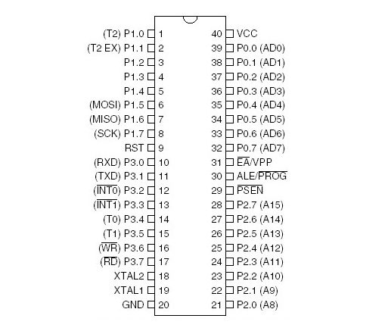

FIG 2:PIN DIAGRAM OF 89S52 IC
2.1.4 PIN DESCRIPTION
Pin Description
VCC
Supply voltage.

GND
Ground.

Port 0
Port 0 is an 8-bit open drain bidirectional I/O port. As an output port, each pin can sink eight TTL inputs. When 1s are written to port 0 pins, the pins can be used as highimpedance inputs.Port 0 can also be configured to be the multiplexed loworder address/data bus during accesses to external program and data memory. In this mode, P0 has internal pullups. Port 0 also receives the code bytes during Flash programming and outputs the code bytes during program verification. External pullups are required during program verification.

Port 1
Port 1 is an 8-bit bidirectional I/O port with internal pullups. The Port 1 output buffers can sink/source four TTL inputs. When 1s are written to Port 1 pins, they are pulled high by the internal pullups and can be used as inputs. As inputs,Port 1 pins that are externally being pulled low will source current (IIL) because of the internal pullups. In addition, P1.0 and P1.1 can be configured to be the timer/counter 2 external count input (P1.0/T2) and the timer/counter 2 trigger input (P1.1/T2EX), respectively, as shown in the following table. Port 1 also receives the low-order address bytes during Flash programming and verification.

Port 2
Port 2 is an 8-bit bidirectional I/O port with internal pullups. The Port 2 output buffers can sink/source four TTL inputs. When 1s are written to Port 2 pins, they are pulled high by
the internal pullups and can be used as inputs. As inputs, Port 2 pins that are externally being pulled low will source current (IIL) because of the internal pullups. Port 2 emits the high-order address byte during fetches from external program memory and during accesses to external data memory that use 16-bit addresses (MOVX @ DPTR). In this application, Port 2 uses strong internal pull-ups when emitting 1s. During accesses to external data memory that use 8-bit addresses (MOVX @ RI), Port 2 emits the contents of the P2 Special Function Register. Port 2 also receives the high-order address bits and some control signals during Flash programming and verification.

Port 3
Port 3 is an 8-bit bidirectional I/O port with internal pullups. The Port 3 output buffers can sink/source four TTL inputs. When 1s are written to Port 3 pins, they are pulled high by the internal pullups and can be used as inputs. As inputs, Port 3 pins that are externally being pulled low will source current (IIL) because of the pullups. Port 3 also serves the functions of various special features of the AT89S52, as shown in the following table. Port 3 also receives some control signals for Flash programming and verification.

RST
Reset input. A high on this pin for two machine cycles while the oscillator is running resets the device. This pin drives High for 96 oscillator periods after the Watchdog times out. The DISRTO bit in SFR AUXR (address 8EH) can be used to disable this feature. In the default state of bit DISRTO, the RESET HIGH out feature is enabled. ALE/PROG Address Latch Enable (ALE) is an output pulse for latching the low byte of the address during accesses to external memory. This pin is also the program pulse input (PROG) during Flash programming. In normal operation, ALE is emitted at a constant rate of 1/6 the oscillator frequency and may be used for external timing or clocking purposes. Note, however, that one ALE pulse is skipped during each access to external data memory. If desired, ALE operation can be disabled by setting bit 0 of SFR location 8EH. With the bit set, ALE is active only during a MOVX or MOVC instruction. Otherwise, the pin is weakly pulled high. Setting the ALE-disable bit has no effect if the microcontroller is in external execution mode.

PSEN
Program Store Enable (PSEN) is the read strobe to external program memory. When the AT89S52 is executing code from external program memory, PSEN is activated twice each machine cycle, except that two PSEN activations are skipped during each access to external data memory.
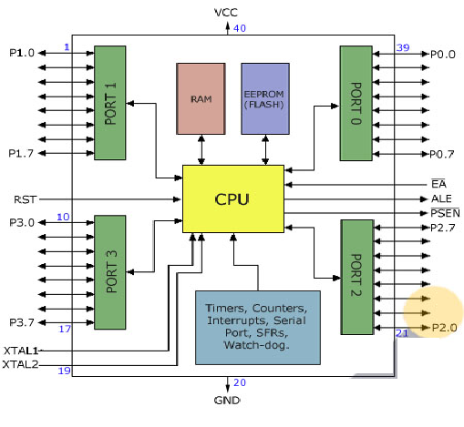
FIG-3 Functional block diagram of micro controller
EA/VPP
External Access Enable. EA must be strapped to GND in order to enable the device to fetch code from external program memory locations starting at 0000H up to FFFFH. Note, however, that if lock bit 1 is programmed, EA will be internally latched on reset. EA should be strapped to VCC for internal program executions. This pin also receives the 12-volt programming enable voltage
(VPP) during Flash programming.

XTAL1
Input to the inverting oscillator amplifier and input to the internal clock operating circuit.
XTAL2
Output from the inverting oscillator amplifier.
The 8052 Oscillator and Clock:
The heart of the 8051 circuitry that generates the clock pulses by which all the internal all internal operations are synchronized. Pins XTAL1 And XTAL2 is provided for connecting a resonant network to form an oscillator. Typically a quartz crystal and capacitors are employed. The crystal frequency is the basic internal clock frequency of the microcontroller. The manufacturers make 8051 designs that run at specific minimum and maximum frequencies typically 1 to 16 MHz.
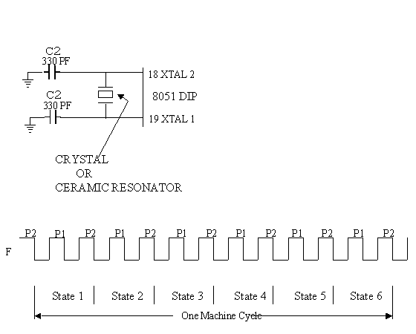
Fig-4 Oscillator and timing circuit
MEMORIES
Types of memory:
The 8052 have three general types of memory. They are on-chip memory, external Code memory and external Ram. On-Chip memory refers to physically existing memory on the micro controller itself. External code memory is the code memory that resides off chip. This is often in the form of an external EPROM. External RAM is the Ram that resides off chip. This often is in the form of standard static RAM or flash RAM.
a) Code memory
Code memory is the memory that holds the actual 8052 programs that is to be run. This memory is limited to 64K. Code memory may be found on-chip or off-chip. It is possible to have 8K of code memory on-chip and 60K off chip memory simultaneously. If only off-chip memory is available then there can be 64K of off chip ROM. This is controlled by pin provided as EA
b) Internal RAM
The 8052 have a bank of 256 bytes of internal RAM. The internal RAM is found on-chip. So it is the fastest Ram available. And also it is most flexible in terms of reading and writing. Internal Ram is volatile, so when 8051 is reset, this memory is cleared. 256 bytes of internal memory are subdivided. The first 32 bytes are divided into 4 register banks. Each bank contains 8 registers. Internal RAM also contains 256 bits, which are addressed from 20h to 2Fh. These bits are bit addressed i.e. each individual bit of a byte can be addressed by the user. They are numbered 00h to FFh. The user may make use of these variables with commands such as SETB and CLR.

Special Function registered memory:
Special function registers are the areas of memory that control specific functionality of the 8052 micro controller.
a) Accumulator (0E0h)
As its name suggests, it is used to accumulate the results of large no of instructions. It can hold 8 bit values.

b) B registers (0F0h)
The B register is very similar to accumulator. It may hold 8-bit value. The b register is only used by MUL AB and DIV AB instructions. In MUL AB the higher byte of the product gets stored in B register. In div AB the quotient gets stored in B with the remainder in A.
- Stack pointer (81h)
The stack pointer holds 8-bit value. This is used to indicate where the next value to be removed from the stack should be taken from. When a value is to be pushed onto the stack, the 8052 first store the value of SP and then store the value at the resulting memory location. When a value is to be popped from the stack, the 8052 returns the value from the memory location indicated by SP and then decrements the value of SP.
d) Data pointer
The SFRs DPL and DPH work together work together to represent a 16-bit value called the data pointer. The data pointer is used in operations regarding external RAM and some instructions code memory. It is a 16-bit SFR and also an addressable SFR.
e) Program counter
The program counter is a 16 bit register, which contains the 2 byte address, which tells the 8052 where the next instruction to execute to be found in memory. When the 8052 is initialized PC starts at 0000h. And is incremented each time an instruction is executes. It is not addressable SFR.
f) PCON (power control, 87h)
The power control SFR is used to control the 8051’s power control modes. Certain operation modes of the 8051 allow the 8051 to go into a type of “sleep mode” which consumes much lee power.
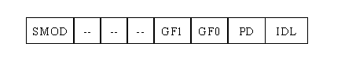
g) TCON (timer control, 88h)
The timer control SFR is used to configure and modify the way in which the 8051’s two timers operate. This SFR controls whether each of the two timers is running or stopped and contains a flag to indicate that each timer has overflowed. Additionally, some non-timer related bits are located in TCON SFR. These bits are used to configure the way in which the external interrupt flags are activated, which are set when an external interrupt occurs.
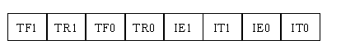

h) TMOD (Timer Mode, 89h)
The timer mode SFR is used to configure the mode of operation of each of the two timers. Using this SFR your program may configure each timer to be a 16-bit timer, or 13 bit timer, 8-bit auto reload timer, or two separate timers. Additionally you may configure the timers to only count when an external pin is activated or to count “events” that are indicated on an external pin.
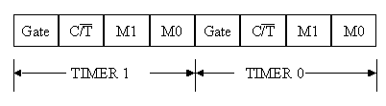

i) TO (Timer 0 low/high, address 8A/8C h)
These two SFRs taken together represent timer 0. Their exact behavior depends on how the timer is configured in the TMOD SFR; however, these timers always count up. What is configurable is how and when they increment in value.
j) T1 (Timer 1 Low/High, address 8B/ 8D h)
These two SFRs, taken together, represent timer 1. Their exact behavior depends on how the timer is configured in the TMOD SFR; however, these timers always count up.
k) P0 (Port 0, address 90h, bit addressable)
This is port 0 latch. Each bit of this SFR corresponds to one of the pins on a micro controller. Any data to be outputted to port 0 is first written on P0 register. For e.g., bit 0 of port 0 is pin P0.0, bit 7 is pin p0.7. Writing a value of 1 to a bit of this SFR will send a high level on the corresponding I/O pin whereas a value of 0 will bring it to low level.
l) P1 (port 1, address 90h, bit addressable)
This is port latch1. Each bit of this SFR corresponds to one of the pins on a micro controller. Any data to be outputted to port 0 is first written on P0 register. For e.g., bit 0 of port 0 is pin P1.0, bit 7 is pin P1.7. Writing a value of 1 to a bit of this SFR will send a high level on the corresponding I/O pin whereas a value of 0 will bring it to low level
m) P2 (port 2, address 0A0h, bit addressable):
This is a port latch2. Each bit of this SFR corresponds to one of the pins on a micro controller. Any data to be outputted to port 0 is first written on P0 register. For e.g., bit 0 of port 0 is pin P2.0, bit 7 is pin P2.7. Writing a value of 1 to a bit of this SFR will send a high level on the corresponding I/O pin whereas a value of 0 will bring it to low level.
n) P3 (port 3, address B0h, bit addressable) :
This is a port latch3. Each bit of this SFR corresponds to one of the pins on a micro controller. Any data to be outputted to port 0 is first written on P0 register. For e.g., bit 0 of port 0 is pin P3.0, bit 7 is pin P3.7. Writing a value of 1 to a bit of this SFR will send a high level on the corresponding I/O pin whereas a value of 0 will bring it to low level.
o) IE (interrupt enable, 0A8h):
The Interrupt Enable SFR is used to enable and disable specific interrupts. The low 7 bits of the SFR are used to enable/disable the specific interrupts, where the MSB bit is used to enable or disable all the interrupts. Thus, if the high bit of IE is 0 all interrupts are disabled regardless of whether an individual interrupt is enabled by setting a lower bit.
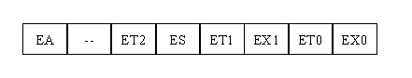
p) IP (Interrupt Priority, 0B8h)
The interrupt priority SFR is used to specify the relative priority of each interrupt. On 8051, an interrupt maybe either low or high priority. An interrupt may interrupt interrupts. For e.g., if we configure all interrupts as low priority other than serial interrupt. The serial interrupt always interrupts the system, even if another interrupt is currently executing. However, if a serial interrupt is executing no other interrupt will be able to interrupt the serial interrupt routine since the serial interrupt routine has the highest priority.
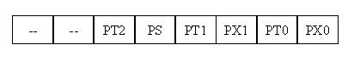
q) PSW (Program Status Word, 0D0h)
The program Status Word is used to store a number of important bits that are set and cleared by 8052 instructions. The PSW SFR contains the carry flag, the auxiliary carry flag, the parity flag and the overflow flag. Additionally, it also contains the register bank select flags, which are used to select, which of the “R” register banks currently in use.
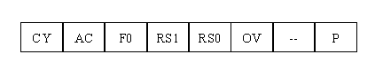
r) SBUF (Serial Buffer, 99h)
SBUF is used to hold data in serial communication. It is physically two registers. One is writing only and is used to hold data to be transmitted out of 8052 via TXD. The other is read only and holds received data from external sources via RXD. Both mutually exclusive registers use address 99h.

2.2 Power Supply
All digital circuits require regulated power supply. In this article we are going to learn how to get a regulated positive supply from the mains supply.
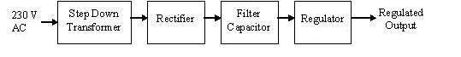
Fig 2.2 Power supply
Figure 2.2 shows the basic block diagram of a fixed regulated power supply. Let us go through each block.
TRANSFORMER
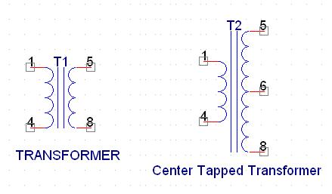
A transformer consists of two coils also called as “WINDINGS” namely PRIMARY & SECONDARY.
They are linked together through inductively coupled electrical conductors also called as CORE. A changing current in the primary causes a change in the Magnetic Field in the core & this in turn induces an alternating voltage in the secondary coil. If load is applied to the secondary then an alternating current will flow through the load. If we consider an ideal condition then all the energy from the primary circuit will be transferred to the secondary circuit through the magnetic field.
So 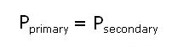
Rectifier
A rectifier is a device that converts an AC signal into DC signal. For rectification purpose we use a diode, a diode is a device that allows current to pass only in one direction i.e. when the anode of the diode is positive with respect to the cathode also called as forward biased condition & blocks current in the reversed biased condition.
Rectifier can be classified as follows:
1) Half Wave rectifier
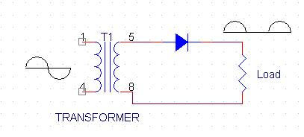
This is the simplest type of rectifier as you can see in the diagram a half wave rectifier consists of only one diode. When an AC signal is applied to it during the positive half cycle the diode is forward biased & current flows through it. But during the negative half cycle diode is reverse biased & no current flows through it. Since only one half of the input reaches the output, it is very inefficient to be used in power supplies.
2) Full wave rectifier
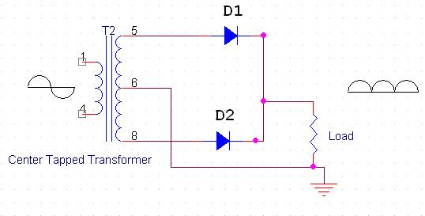
Half wave rectifier is quite simple but it is very inefficient, for greater efficiency we would like to use both the half cycles of the AC signal. This can be achieved by using a center tapped transformer i.e. we would have to double the size of secondary winding & provide connection to the center. So during the positive half cycle diode D1 conducts & D2 is in reverse biased condition. During the negative half cycle diode D2 conducts & D1 is reverse biased. Thus we get both the half cycles across the load.
One of the disadvantages of Full Wave Rectifier design is the necessity of using a center tapped transformer, thus increasing the size & cost of the circuit. This can be avoided by using the Full Wave Bridge Rectifier.
3) Bridge Rectifier
.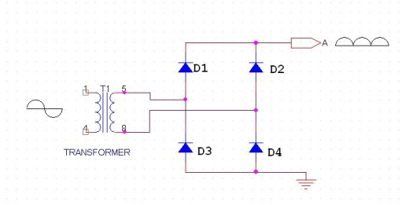
As the name suggests it converts the full wave i.e. both the positive & the negative half cycle into DC thus it is much more efficient than Half Wave Rectifier & that too without using a center tapped transformer thus much more cost effective than Full Wave Rectifier.
Full Bridge Wave Rectifier consists of four diodes namely D1, D2, D3 and D4. During the positive half cycle diodes D1 & D4 conduct whereas in the negative half cycle diodes D2 & D3 conduct thus the diodes keep switching the transformer connections so we get positive half cycles in the output.
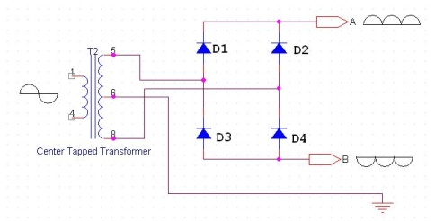
If we use a center tapped transformer for a bridge rectifier we can get both positive & negative half cycles which can thus be used for generating fixed positive & fixed negative voltages.
Filter Capacitor
Even though half wave & full wave rectifier give DC output, none of them provides a constant output voltage. For this we require to smoothen the waveform received from the rectifier. This can be done by using a capacitor at the output of the rectifier this capacitor is also called as “FILTER CAPACITOR” or “SMOOTHING CAPACITOR” or “RESERVOIR CAPACITOR”. Even after using this capacitor a small amount of ripple will remain.
We place the Filter Capacitor at the output of the rectifier the capacitor will charge to the peak voltage during each half cycle then will discharge its stored energy slowly through the load while the rectified voltage drops to zero, thus trying to keep the voltage as constant as possible.
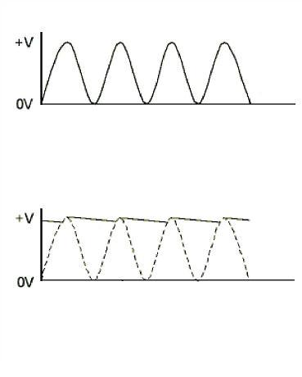
If we go on increasing the value of the filter capacitor then the Ripple will decrease. But then the costing will increase. The value of the Filter capacitor depends on the current Consumed by the circuit, the frequency of the waveform & the accepted ripple.
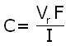
Where,
Vr= accepted ripple voltage.( should not be more than 10% of the voltage)
I= current consumed by the circuit in Amperes.
F= frequency of the waveform. A half wave rectifier has only one peak in one cycle so F=25hz
Whereas a full wave rectifier has Two peaks in one cycle so F=100hz.
Voltage Regulator
A Voltage regulator is a device which converts varying input voltage into a constant regulated output voltage. Voltage regulator can be of two types
1) Linear Voltage Regulator
Also called as Resistive Voltage regulator because they dissipate the excessive voltage resistively as heat.
2) Switching Regulators.
They regulate the output voltage by switching the Current ON/OFF very rapidly. Since their output is either ON or OFF it dissipates very low power thus achieving higher efficiency as compared to linear voltage regulators. But they are more complex & generate high noise due to their switching action. For low level of output power switching regulators tend to be costly but for higher output wattage they are much cheaper than linear regulators.
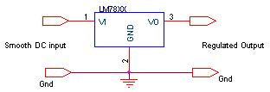
After filtering the rectifier output the signal is given to a voltage regulator. The maximum input voltage that can be applied at the input is 35V.

2.2.1 Circuit diagram
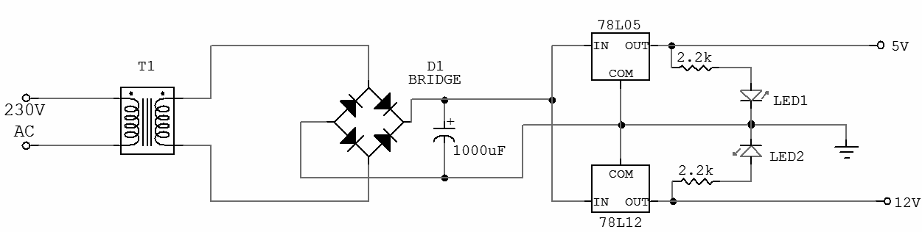
Fig 2.2.1. Circuit Diagram of power supply
IC 7805:
7805 is an integrated three-terminal positive fixed linear voltage regulator. It supports an input voltage of 10 volts to 35 volts and output voltage of 5 volts. It has a current rating of 1 amp although lower current models are available. Its output voltage is fixed at 5.0V. The 7805 also has a built-in current limiter as a safety feature. 7805 is manufactured by many companies, including National Semiconductors and Fairchild Semiconductors.

2.3 LCD
To display interactive messages we're using LCD Module. We take a look at an smart LCD show of lines, sixteen characters in keeping with line this is interfaced to the controllers. The protocol (handshaking) for the display is as proven. Whereas D0 to D7th bit is the Data strains, RS, RW and EN pins are the control pins and last pins are +5V, -5V and GND to offer supply. Where RS is the Register Select, RW is the Read Write and EN is the Enable pin.
The display consists of internal byte-wide registers, one for instructions (RS=zero) and the second for characters to be displayed (RS=1). It additionally includes a user-programmed RAM vicinity (the man or woman RAM) that may be programmed to generate any favored character that can be fashioned the usage of a dot matrix. To distinguish among these two facts regions, the hex command byte 80 could be used to indicate that the display RAM deal with 00h can be selected.Port1 is used to grant the command or statistics type, and ports 3.2 to3.4 provide register pick and study/write ranges.
The show takes various quantities of time to perform the features as listed. LCD bit 7 is monitored for common sense high (busy) to ensure the display is overwritten.
Liquid Crystal Display also called as LCD may be very useful in offering user interface in addition to for debugging purpose. The most not unusual sort of LCD controller is HITACHI 44780 which provides a easy interface between the controller & an LCD. These LCD's are quite simple to interface with the controller as well as are price effective.
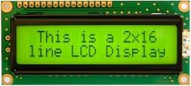
Fig 2.6 2x16 LCD Display
The most commonly used ALPHANUMERIC displays are 1x16 (Single Line & 16 characters), 2x16 (Double Line & 16 character per line) & 4x20 (four lines & Twenty characters per line). The LCD requires 3 control lines (RS, R/W & EN) & 8 (or 4) data lines. The number on data lines depends on the mode of operation. If operated in 8-bit mode then 8 data lines + 3 control lines i.e. total 11 lines are required. And if operated in 4-bit mode then 4 data lines + 3 control lines i.e. 7 lines are required. How do we decide which mode to use? It’s simple if you have sufficient data lines you can go for 8 bit mode & if there is a time constrain i.e. display should be faster then we have to use 8-bit mode because basically 4-bit mode takes twice as more time as compared to 8-bit mode.
Pin | Symbol | Function
1 | Vss | Ground
2 | Vdd | Supply Voltage
3 | Vo | Contrast Setting
4 | RS | Register Select
5 | R/W | Read/Write Select
6 | En | Chip Enable Signal
7-14 | DB0-DB7 | Data Lines
15 | A/Vee | Gnd for the backlight
16 | K | Vcc for backlight
Table 1
When RS is low (zero), the statistics is to be handled as a command. When RS is excessive (1), the records being sent is taken into consideration as textual content data which must be displayed on the screen. When R/W is low (0), the facts at the statistics bus is being written to the LCD. When RW is high (1), the program is effectively analyzing from the LCD. Most of the instances there's no need to read from the LCD so this line can immediately be linked to Gnd for that reason saving one controller line.
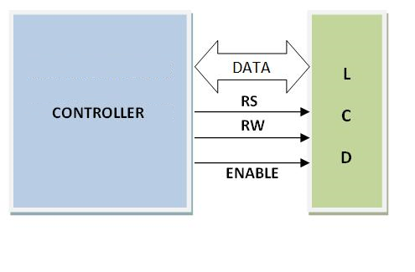
Fig 2.6.1 LCD Interfacing

2.3.1 Commands Used In LCD
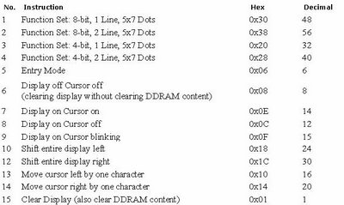

2.4 PIR SENSOR

What is a PIR sensor?
PIR sensors allow you to sense motion, almost always used to detect whether a human has moved in or out of the sensors range. They are small, inexpensive, low-power, easy to use and don't wear out. For that reason they are commonly found in appliances and gadgets used in homes or businesses. They are often referred to as PIR, "Passive Infrared", "Pyroelectric", or "IR motion" sensors.
PIRs are basically made of a pyroelectric sensor (which you can see above as the round metal can with a rectangular crystal in the center), which can detect levels of infrared radiation. Everything emits some low level radiation, and the hotter something is, the more radiation is emitted. The sensor in a motion detector is actually split in two halves. The reason for that is that we are looking to detect motion (change) not average IR levels. The two halves are wired up so that they cancel each other out. If one half sees more or less IR radiation than the other, the output will swing high or low.
Along with the pyroelectic sensor is a bunch of supporting circuitry, resistors and capacitors. It seems that most small hobbyist sensors use the BISS0001 ("Micro Power PIR Motion Detector IC") , undoubtedly a very inexpensive chip. This chip takes the output of the sensor and does some minor processing on it to emit a digital output pulse from the analog sensor.
For many basic projects or products that need to detect when a person has left or entered the area, or has approached, PIR sensors are great. They are low power and low cost, pretty rugged, have a wide lens range, and are easy to interface with. Note that PIRs won't tell you how many people are around or how close they are to the sensor, the lens is often fixed to a certain sweep and distance (although it can be hacked somewhere) and they are also sometimes set off by house pets. Experimentation is key!

PIR MODULE
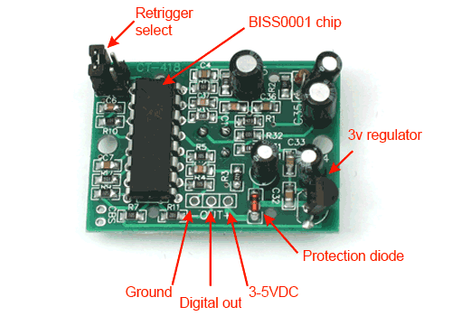
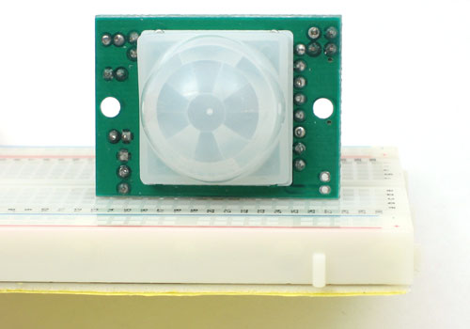
FIG -4 PIR MODULE
Some basic stats
These stats are for the PIR sensor in the Adafruit shop which is very much like the Parallax one . Nearly all PIRs will have slightly different specifications, although they all pretty much work the same. If there's a datasheet, you'll want to refer to it
- Size: Rectangular
- Price: $10.00 at the Adafruit shop
- Output: Digital pulse high (3V) when triggered (motion detected) digital low when idle (no motion detected). Pulse lengths are determined by resistors and capacitors on the PCB and differ from sensor to sensor.
- Sensitivity range: up to 20 feet (6 meters) 110° x 70° detection range
- Power supply:3.3V - 5V input voltage,
- BIS0001 Datasheet (the decoder chip used)
- RE200B datasheet (most likely the PIR sensing element used)
- NL11NH datasheet (equivalent lens used)
- A great page on PIR sensors from GLOLAB \\
- NYU sensor report
How Does It Work?
PIR sensors are more complicated than many of the other sensors explained in these tutorials (like photocells, FSRs and tilt switches) because there are multiple variables that affect the sensors input and output. To begin explaining how a basic sensor works, we'll use this rather nice diagram (if anyone knows where it originates plz let me know).
The PIR sensor itself has two slots in it, each slot is made of a special material that is sensitive to IR. The lens used here is not really doing much and so we see that the two slots can 'see' out past some distance (basically the sensitivity of the sensor). When the sensor is idle, both slots detect the same amount of IR, the ambient amount radiated from the room or walls or outdoors. When a warm body like a human or animal passes by, it first intercepts one half of the PIR sensor, which causes a positive differential change between the two halves. When the warm body leaves the sensing area, the reverse happens, whereby the sensor generates a negative differential change. These change pulses are what is detected.
The IR sensor itself is housed in a hermetically sealed metal can to improve noise/temperature/humidity immunity. There is a window made of IR-transmissive material (typically coated silicon since that is very easy to come by) that protects the sensing element. Behind the window are the two balanced sensors.

Lenses
PIR sensors are rather generic and for the most part vary only in price and sensitivity. Most of the real magic happens with the optics. This is a pretty good idea for manufacturing: the PIR sensor and circuitry is fixed and costs a few dollars. The lens costs only a few cents and can change the breadth, range, sensing pattern, very easily.
In the diagram up top, the lens is just a piece of plastic, but that means that the detection area is just two rectangles. Usually we'd like to have a detection area that is much larger. To do that, we use a simple lens such as those found in a camera: they condenses a large area (such as a landscape) into a small one (on film or a CCD sensor). For reasons that will be apparent soon, we would like to make the PIR lenses small and thin and moldable from cheap plastic, even though it may add distortion. For this reason the sensors are actually Fresnel lenses :

Testing PIR
Once you have your PIR wired up its a good idea to do a simple test to verify that it works the way you expect. This test is also good for range testing. Simply connect 3-4 alkaline batteries (make sure you have more than 3.5VDC out but less than 6V by checking with your multimeter!) and connect ground to the - pin on your PIR. Power goes to the + pin. Then connect a basic red LED (red LEDs have lower forward voltages than green or blue so they work better with only the 3.3v output) and a 220Ω resistor (any value from 100Ω to 1.0KΩ will do fine) to the out pin as shown. Of course, the LED and resistor can swap locations as long as the LED is oriented connection and connects between out and ground.
Now when the PIR detects motion, the output pin will go "high" to 3.3V and light up the LED!
Once you have the breadboard wired up, insert batteries and wait 30-60 seconds for the PIR to 'stabilize'. During that time the LED may blink a little. Wait until the LED is off and then move around in front of it, waving a hand, etc, to see the LED light up!

2.5 LDR

Working
A photo resistor or Light Dependent Resistor or CdS Cell is a resistor whose resistance decreases with increasing incident light intensity. It can also be referred to as a photoconductor. A photo resistor is made of a high resistance semiconductor. If light falling on the device is of high enough frequency, photons absorbed by the semiconductor give bound electrons enough energy to jump into the conduction band. The resulting free electron (and its hole partner) conduct electricity, thereby lowering resistance.
A photoelectric device can be either intrinsic or extrinsic. An intrinsic semiconductor has its own charge carriers and is not an efficient semiconductor, e.g. silicon. In intrinsic devices the only available electrons are in the valence band, and hence the photon must have enough energy to excite the electron across the entire band gap. Extrinsic devices have impurities, also called dopants, added whose ground state energy is closer to the conduction band; since the electrons don't have as far to jump, lower energy photons (i.e., longer wavelengths and lower frequencies) are sufficient to trigger the device. If a sample of silicon has some of its atoms replaced by phosphorus atoms (impurities), there will be extra electrons available for conduction. This is an example of an extrinsic semiconductor.

FIG -5 :LDR
A Light Dependent Resistor (LDR, photoconductor, or photocell) is a device which has a resistance which varies according to the amount of light falling on its surface. They will be having a resistance of 1 MOhm in total darkness, and a resistance of a 1 to 10 of kOhm in bright light. A photoelectric device can be either intrinsic or extrinsic.
Applications:
An LDR can even be used in a simple remote control circuit using the backlight of a mobile phone to turn on a device - call the mobile from anywhere in the world, it lights up the LDR, and lighting can be turned on remotely!
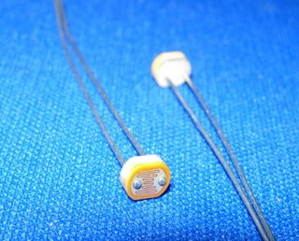
There are two basic circuits using light dependent resistors - the first is activated by darkness, the second is activated by light.
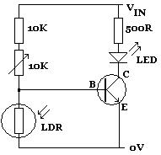
In the circuit diagram on the left, the led lights up whenever the LDR is in darkness. The 10K variable resistor is used to fine-tune the level of darkness required before the LED lights up. The 10K standard resistor can be changed as required to achieve the desired effect, although any replacement must be at least 1K to protect the transistor from being damaged by excessive current.

By swapping the LDR over with the 10K and 10K variable resistors , the circuit will be activated instead by light. Whenever sufficient light falls on the LDR (manually fine-tuned using the 10K variable resistor), the LED will light up.

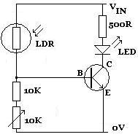

The circuits shown above are not practically useful. In a real world circuit, the LED (and resistor) between the positive voltage input (Vin) and the collector (C) of the transistor would be replaced with the device to be powered.
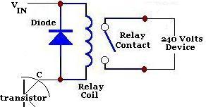
Typically a relay is used - particularly when the low voltage light detecting circuit is used to switch on (or off) a 240V mains powered device. A diagram of that part of the circuit is shown above. When darkness falls (if the LDR circuit is configured that way around), the relay is triggered and the 240V device - for example a security light - switches on.
Measure Light Intensity using Light Dependent Resistor (LDR):
The relationship between the resistance RL and light intensity Lux for a typical LDR is
RL = 500 / Lux Kohm
With the LDR connected to 5V through a 3.3K resistor, the output voltage of the LDR is
Vo = 5*RL / (RL+3.3)

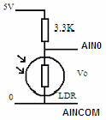
Reworking the equation, we obtain the light intensity
Lux = (2500/Vo - 500)/3

2.6 ULN2003
ULN is mainly suited for interfacing between low-level circuits and multiple peripheral power loads. The series ULN20XX high voltage, high current Darlington arrays feature continuous load current ratings. The driving circuitry in- turn decodes the coding and conveys the necessary data to the stepper motor, this module aids in the movement of the arm through steppers
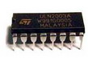
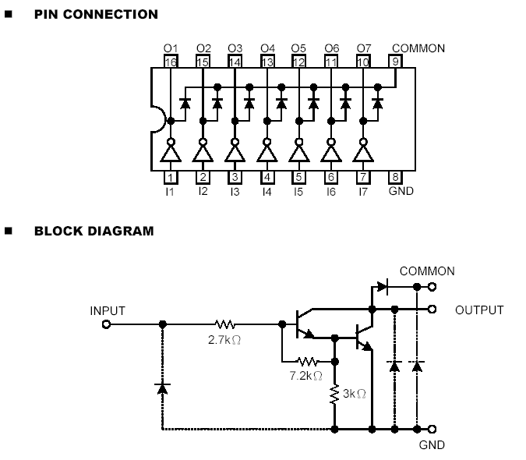
FIG-6 ULN2003
The driver makes use of the ULN2003 driver IC, which contains an array of 7 power Darlington arrays, each capable of driving 500mA of current. At an approximate duty cycle, depending on ambient temperature and number of drivers turned on, simultaneously typical power loads totaling over 230w can be controlled.
The device has base resistors, allowing direct connection to any common logic family. All the emitters are tied together and brought out to a separate terminal. Output protection diodes are included; hence the device can drive inductive loads with minimum extra components. Typical loads include relays, solenoids, stepper motors, magnetic print hammers, multiplexed LED, incandescent displays and heaters.
Darlington Pair
What is a Darlington Pair?
A Darlington pair is two transistors that act as a single transistor but with a much higher current gain.
What is current gain?
Transistors have a characteristic called current gain. This is referred to as its hFE. The amount of current that can pass through the load when connected to a transistor that is turned on equals the input current x the gain of the transistor (hFE) The current gain varies for different transistor and can be looked up in the data sheet for the device. Typically, it may be 100. This would mean that the current available to drive the load would be 100 times larger than the input to the transistor.

Why use a Darlington Pair?
In some application the amount of input current available to switch on a transistor is very low. This may mean that a single transistor may not be able to pass sufficient current required by the load.
As stated earlier this equals the input current x the gain of the transistor (hFE). If it is not be possible to increase the input current then we need to increase the gain of the transistor. This can be achieved by using a Darlington Pair.
A Darlington Pair acts as one transistor but with a current gain that equals:
Total current gain (hFE total) = current gain of transistor 1 (hFE t1) x current gain of transistor 2 (hFE t2)
So for example if you had two transistors with a current gain (hFE) = 100:
(hFE total) = 100 x 100
(hFE total) = 10,000
You can see that this gives a vastly increased current gain when compared to a single transistor. Therefore, this will allow a very low input current to switch a much bigger load current.
Base Activation Voltage
Normally to turn on a transistor the base input voltage of the transistor will need to be greater that 0.7V. As two transistors are used in a Darlington Pair this value is doubled. Therefore, the base voltage will need to be greater than 0.7V x 2 = 1.4V.
It is also worth noting that the voltage drops across collector and emitter pins of the Darlington Pair when the turn on will be around 0.9V Therefore if the supply voltage is 5V (as above) the voltage across the load will be will be around 4.1V (5V – 0.9V)

2.7 LED STREET LIGHTS

LED Street Lights are energy-efficient, long-lasting, and environmentally friendly lighting solutions used in public spaces, particularly for road and street illumination. They are an upgrade over traditional street lighting options, such as high-pressure sodium (HPS), mercury vapor, and metal halide lamps, due to their low power consumption, reduced maintenance costs, and enhanced visibility.
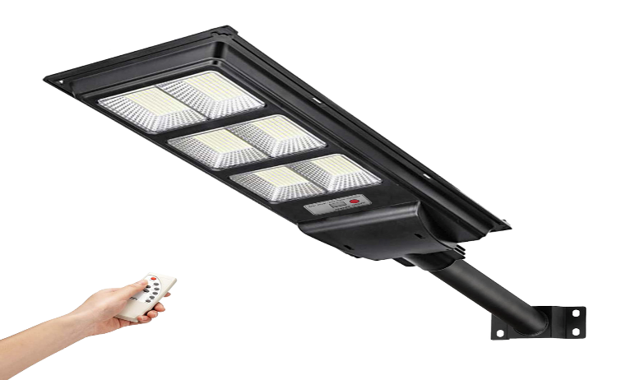
FIG-7 LED STREET LIGHTS
There is an asymmetrical lens in front of LEDs in LED street lights. This lens distributes the light with wide angle in horizontal position and with narrow angle in vertical position. Therefore the light will homogeneously distributed to the surface of the road.
LED street lights must have a minimum IP65 protection class as they are used in outdoor conditions. Street lighting must comply with the international standard EN-60598-2-3 and this conformity must be as certificate
Here is a detailed look at LED street lights, including their specifications, benefits, and applications:
Specification | Description
Light Output (Lumens) | Typically 1,500 – 20,000 lumens, depending on application and street width.
Color Temperature | Generally ranges from 2700K (warm white) to 6500K (cool white); 4000K–5000K is common for street lighting.
Luminous Efficacy | High efficiency, typically around 100–150 lumens per watt, which is much higher than conventional lamps.
Power Consumption | Varies from 20W to 150W or more, with LED efficiency enabling lower wattage while providing the same brightness.
Lifespan | 50,000 to 100,000 hours, drastically reducing the need for frequent replacements.
Beam Angle | Ranges from 70° to 120°, directing light only where it’s needed and reducing light pollution.
Color Rendering Index (CRI) | Usually above 70, improving visibility and color accuracy over traditional lighting.
IP Rating | IP65 or higher for water and dust resistance, suitable for outdoor conditions.
Surge Protection | Equipped with surge protection (typically 6Kv or higher) to handle power fluctuations.
Material | Often made from die-cast aluminum with a powder-coated finish, offering durability and corrosion resistance.
Operating Temperature | Typically -40°C to +50°C, suitable for various climates.
Dimmability | Can be dimmed or configured with sensors for adaptive brightness control based on time of day or activity.
Smart Features | Can include options for smart controls, such as remote monitoring, automation, and IoT connectivity.
Power Factor | Generally greater than 0.9, ensuring efficient energy use and reducing wasteful power loss.
Benefits of LED Street Lights
- Energy Efficiency: LEDs use up to 50% less energy than traditional lighting systems, leading to significant cost savings.
- Long Lifespan: Reduced replacement frequency due to long operating life, resulting in lower maintenance costs.
- Improved Safety: High CRI and uniform lighting enhance visibility, which improves safety for drivers, cyclists, and pedestrians.
- Environmental Impact: LEDs contain no toxic substances like mercury and produce less CO₂ than other lighting options.
- Reduced Light Pollution: Directional lighting minimizes glare and “skyglow,” reducing light pollution in urban environments.
- Smart Integration: Many LED street lights can be integrated with smart city infrastructure, enabling remote monitoring, automated dimming, and energy optimization.

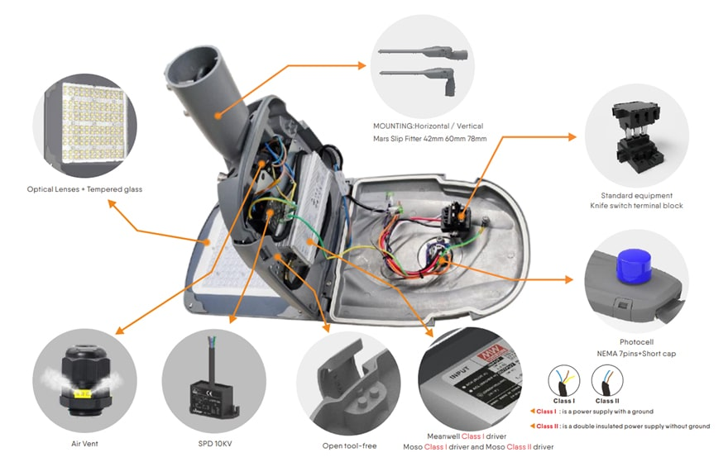
Applications
- Urban and Rural Roads
- Highways and Expressways
- Pedestrian Pathways and Parks
- Parking Lots and Outdoor Campuses
- Industrial and Commercial Areas
LED street lights are becoming the standard in outdoor lighting due to their cost-effectiveness, energy efficiency, and ability to provide safe, high-quality illumination for a wide range of public spaces.
This combination of PIR and LDR sensors in street lights is highly effective for applications in residential areas, parks, and other locations where adaptive lighting can improve safety and conserve energy.

CHAPTER- III
CIRCUIT DIAGRAM

3.1 Circuit diagram
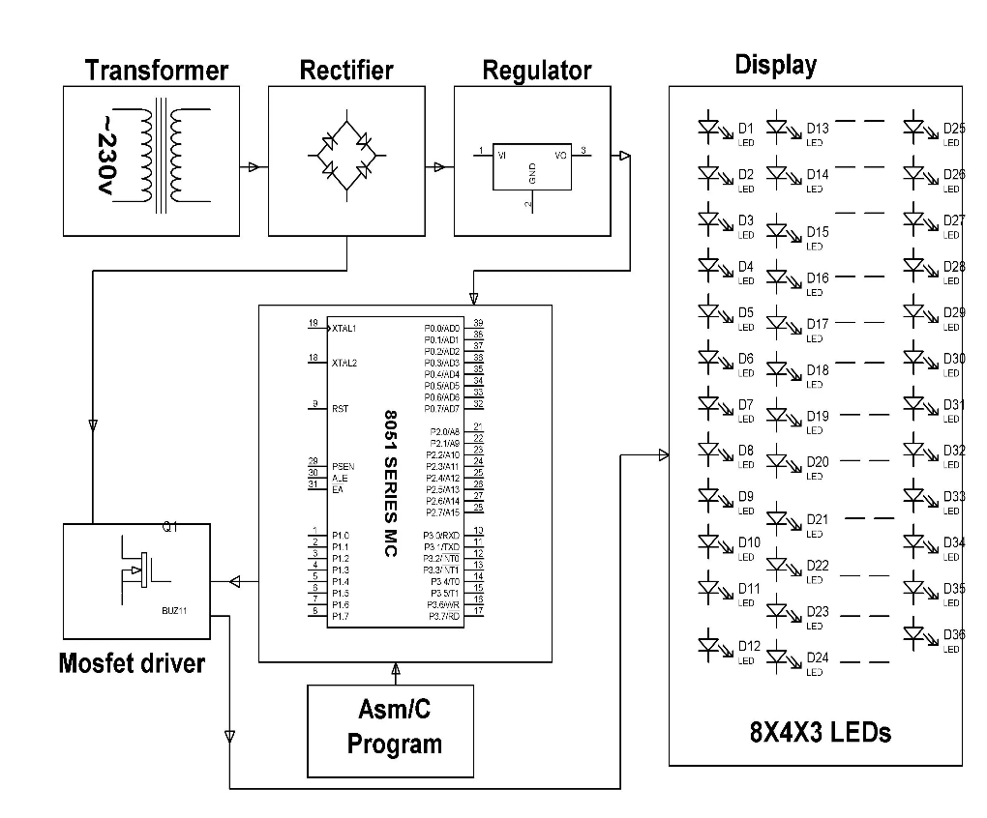
FIG-1: B-3 sensor based street lights diagram

Working of B-3 Sensor-Based Street Light Circuit
The B-3 sensor-based street light system automatically controls streetlights depending on ambient light levels. It turns ON the lights at night and OFF during the day using an AT89S52 microcontroller.

1. Components Required
- AT89S52 Microcontroller
- B-3 Sensor (LDR or IR-based sensor module)
- Relay Module (for controlling AC lights)
- Transistor (e.g., BC547) for driving the relay
- Resistors & Capacitors (for pull-up and stability)
- LED (for simulation)
- Power Supply (5V for the controller, 12V for relay if required)

2. Circuit Diagram Explanation

a) Power Supply Section
- The microcontroller operates at 5V DC, which is provided by a regulated power supply (7805 voltage regulator).
- The relay may require 12V DC for operation.

b) Sensor Section (B-3 Sensor)
- The B-3 sensor (LDR + comparator circuit) is connected to P1.0 of the AT89S52.
- The LDR (Light Dependent Resistor) reduces resistance in bright light and increases resistance in darkness.
- The comparator (such as LM358) compares LDR voltage with a reference voltage and sends LOW (0) or HIGH (1) signals to the microcontroller.

c) Microcontroller Control
- The AT89S52 reads the sensor input and decides whether to turn the light ON or OFF.
- If sensor output = LOW (0) → Dark detected → Turns ON the street light (P2.0 HIGH).
- If sensor output = HIGH (1) → Brightness detected → Turns OFF the street light (P2.0 LOW).

d) Relay and Street Light Control
- The microcontroller controls a BC547 transistor (acts as a switch) to drive the relay module.
- When P2.0 is HIGH, the transistor conducts → Relay is activated → Street light turns ON.
- When P2.0 is LOW, the transistor turns OFF → Relay deactivates → Street light turns OFF.

3. Working Flowchart
- Power ON the system
- Read the B-3 sensor value (P1.0)
  - If LOW (Darkness detected) → Activate Relay → Turn ON streetlight.
  - If HIGH (Brightness detected) → Deactivate Relay → Turn OFF streetlight.
- Repeat the process continuously.

4. Advantages
- Automatic Operation → No manual intervention needed.
- Energy Saving → Lights operate only when needed.
- Scalability → Can be extended with solar panels or IoT for remote monitoring.

3.2 Source Code
Here's an AT89S52 microcontroller program for a B-3 sensor-based street light system. The B-3 sensor (LDR or IR sensor) will detect ambient light levels, and based on that, it will turn street lights ON or OFF. This program is written in embedded C using the Keil compiler.

Working Principle:
- The B-3 sensor detects light intensity.
- If the intensity is low (nighttime), the street lights will turn ON.
- If the intensity is high (daytime), the street lights will turn OFF.

Circuit Components:
- AT89S52 Microcontroller
- B-3 Light Sensor (LDR or IR-based sensor)
- Relay Module (to control AC street lights)
- LEDs (for simulation of street lights)
- Transistor (to drive relay if necessary)
- Power Supply (5V for the controller, relay supply as needed)

Code for AT89S52:

#include <reg51.h>

// Define pins
sbit sensor = P1^0; // B-3 Sensor connected to P1.0
sbit light = P2^0; // Street Light connected to P2.0

void delay(unsigned int time) {
unsigned int i, j;
for (i = 0; i < time; i++)
for (j = 0; j < 1275; j++);
}

void main() {
while (1) {
if (sensor == 0) { // If sensor detects darkness (LDR high resistance)
light = 1; // Turn ON street light
} else {
light = 0; // Turn OFF street light
}
delay(500); // Small delay to avoid flickering
}
}

Explanation:
- The B-3 sensor is connected to P1.0 and acts as an input.
- The street light (relay or LED) is connected to P2.0 as output.
- If the sensor detects darkness (low light level), it sets P2.0 high, turning ON the street light.
- If the sensor detects brightness (daytime), it turns OFF the light.
- A small delay is used to prevent rapid switching due to sensor noise.

Enhancements:
- Use an op-amp as a comparator for better sensitivity.
- Implement PWM dimming instead of just ON/OFF control.
- Add an RTC (Real-Time Clock) module for scheduled lighting.

CHAPTER- IV
OUTPUT IMAGES

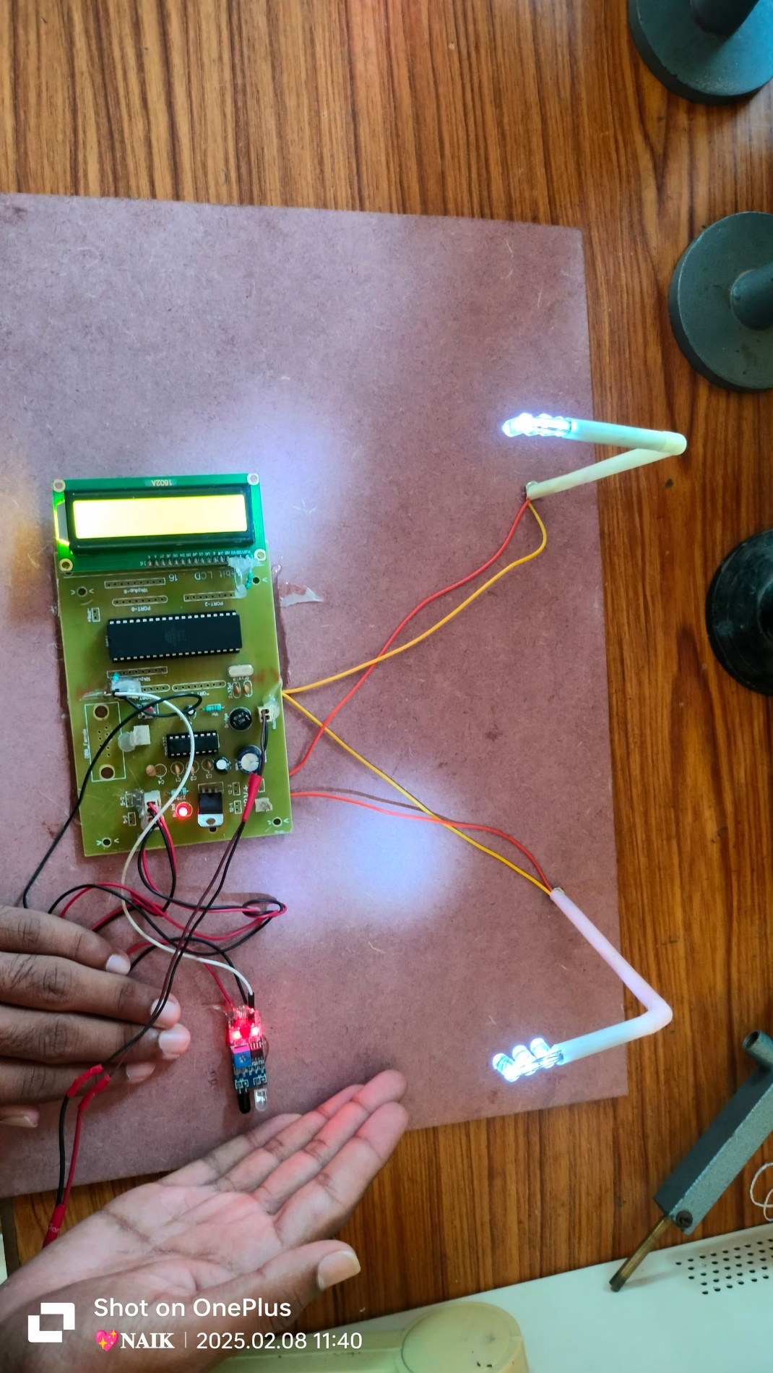

CHAPTER-V
SOFTWARE DEVELOPMENT

5.1 Introduction:
In this chapter the software used and the language in which the program code is defined is mentioned and the program code dumping tools are explained. The chapter also documents the development of the program for the application. This program has been termed as “Source code”. Before we look at the source code we define the two header files that we have used in the code.

5.2 Tools Used:
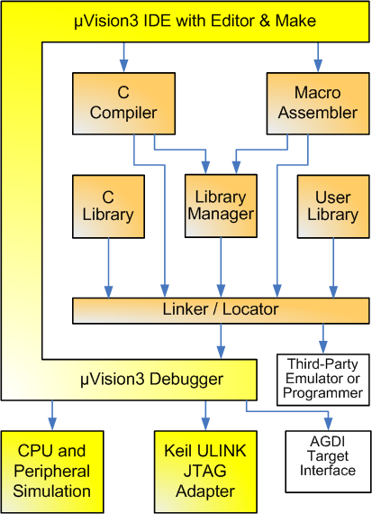
Figure 5.2 Keil Software- internal stages

5.3 C51 Compiler & A51 Macro Assembler:
Source files are created by the µVision IDE and are passed to the C51 Compiler or A51 Macro Assembler. The compiler and assembler process source files and create replaceable object files.
The Keil C51 Compiler is a full ANSI implementation of the C programming language that supports all standard features of the C language. In addition, numerous features for direct support of the 8051 architecture have been added.

5.4 START µVISION

What's New in µVision3?
µVision3 adds many new features to the Editor like Text Templates, Quick Function Navigation, and Syntax Coloring with brace high lighting Configuration Wizard for dialog based startup and debugger setup. µVision3 is fully compatible to µVision2 and can be used in parallel with µVision2.
What is µVision3?
µVision3 is an IDE (Integrated Development Environment) that helps you write, compile, and debug embedded programs. It encapsulates the following components:
- A project manager.
- A make facility.
- Tool configuration.
- Editor.
- A powerful debugger.

To help you get started, several example programs (located in the \C51\Examples, \C251\Examples, \C166\Examples, and \ARM\...\Examples) are provided.

- HELLO is a simple program that prints the string "Hello World" using the Serial Interface.
- MEASURE is a data acquisition system for analog and digital systems.
- TRAFFIC is a traffic light controller with the RTX Tiny operating system.
- SIEVE is the SIEVE Benchmark.
- DHRY is the Dhrystone Benchmark.
- WHETS are the Single-Precision Whetstone Benchmark.
Additional example programs not listed here are provided for each device architecture.

BUILDING AN APPLICATION IN µvision

To build (compile, assemble, and link) an application in µVision2, you must:
Select Project -(forexample,166\EXAMPLES\HELLO\HELLO.UV2).
Select Project - Rebuild all target files or Build target.
µVision2 compiles, assembles, and links the files in your project.
Creating Your Own Application in µVision2
To create a new project in µVision2, you must:
- Select Project - New Project.
- Select a directory and enter the name of the project file.
- Select Project - Select Device and select an 8051, 251, or C16x/ST10 device from the Device Database™.
- Create source files to add to the project.
- Select Project - Targets, Groups, Files. Add/Files, select Source Group1, and add the source files to the project.
- Select Project - Options and set the tool options. Note when you select the target device from the Device Database™ all special options are set automatically. You typically only need to configure the memory map of your target hardware. Default memory model settings are optimal for most applications.
- Select Project - Rebuild all target files or Build target.

Debugging an Application in µVision2
To debug an application created using µVision2, you must:
- Select Debug - Start/Stop Debug Session.
- Use the Step toolbar buttons to single-step through your program. You may enter G, main in the Output Window to execute to the main C function.
- Open the Serial Window using the Serial #1 button on the toolbar.
Debug your program using standard options like Step, Go, Break, and so on.

Starting µVision2 and Creating a Project
µVision2 is a standard Windows application and started by clicking on the program icon. To create a new project file select from the µVision2 menu
Project – New Project…. This opens a standard Windows dialog that asks you for the new project file name.
We suggest that you use a separate folder for each project. You can simply use the icon Create New Folder in this dialog to get a new empty folder. Then select this folder and enter the file name for the new project, i.e. Project1. µVision2 creates a new project file with the name PROJECT1.UV2 which contains a default target and file group name. You can see these names in the Project.

Window – Files.
Now use from the menu Project – Select Device for Target and select a CPU for your project. The Select Device dialog box shows the µVision2 device database. Just select the microcontroller you use. We are using for our examples the Philips 80C51RD+ CPU. This selection sets necessary tool options for the 80C51RD+ device and simplifies in this way the tool Configuration

Building Projects and Creating a HEX Files
Typical, the tool settings under Options – Target are all you need to start a new application. You may translate all source files and line the application with a click on the Build Target toolbar icon. When you build an application with syntax errors, µVision2 will display errors and warning messages in the Output Window – Build page. A double click on a message line opens the source file on the correct location in a µVision2 editor window. Once you have successfully generated your application you can start debugging.
After you have tested your application, it is required to create an Intel HEX file to download the software into an EPROM programmer or simulator. µVision2 creates HEX files with each build process when Create HEX files under Options for Target – Output is enabled. You may start your PROM programming utility after the make process when you specify the program under the option Run User Program #1.

5.5 Overview Of Keil Uvision Software
Click on the Keil uVision Icon on Desktop
The following fig will appear


Click on the Project menu from the title bar
Then Click on New Project

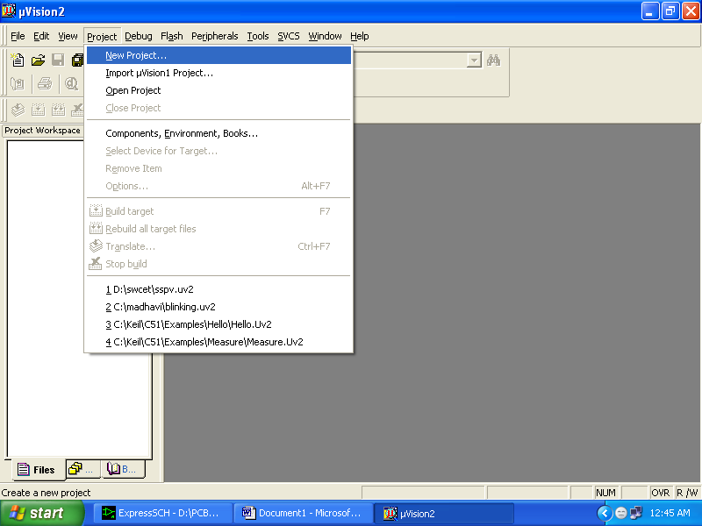

Save the Project by typing suitable project name with no extension in u r own folder sited in either C:\ or D:\

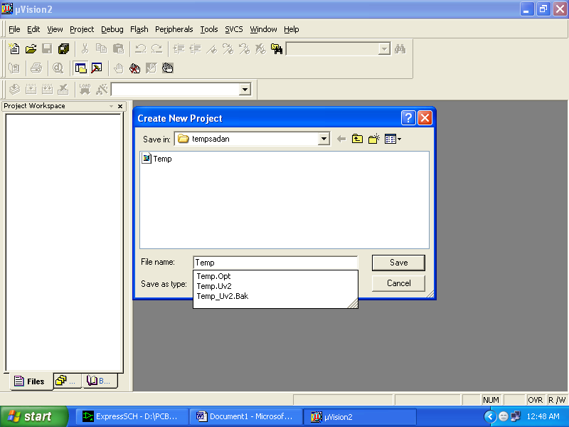

Then Click on Save button above.
Select the component for u r project. i.e. Atmel……
Click on the + Symbol beside of Atmel

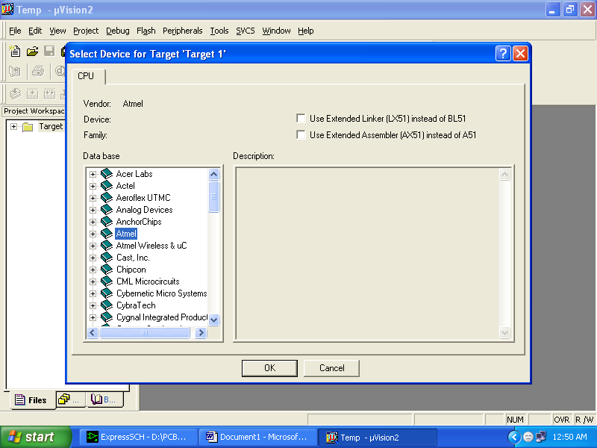

Select AT89S52 as shown below

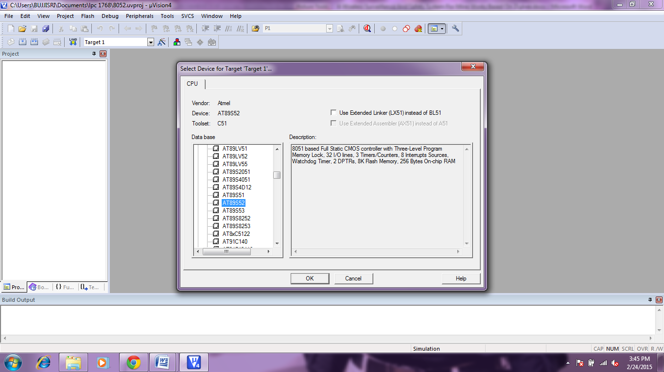

Then Click on “OK”
The Following fig will appear

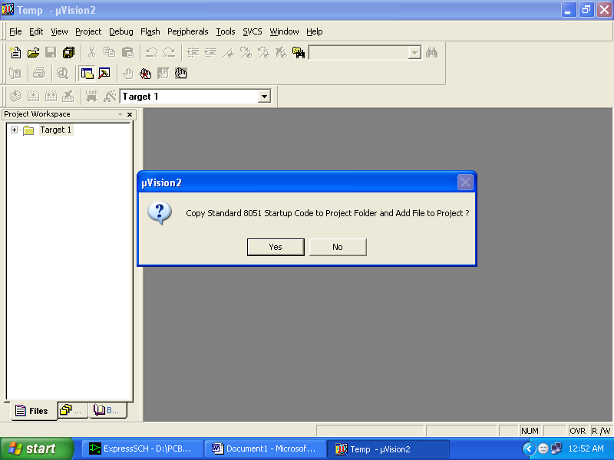

Then Click either YES or NO………mostly “NO”
Now your project is ready to USE
Now double click on the Target1, you would get another option “Source group 1” as shown in next page.

Click on the file option from menu bar and select “new”

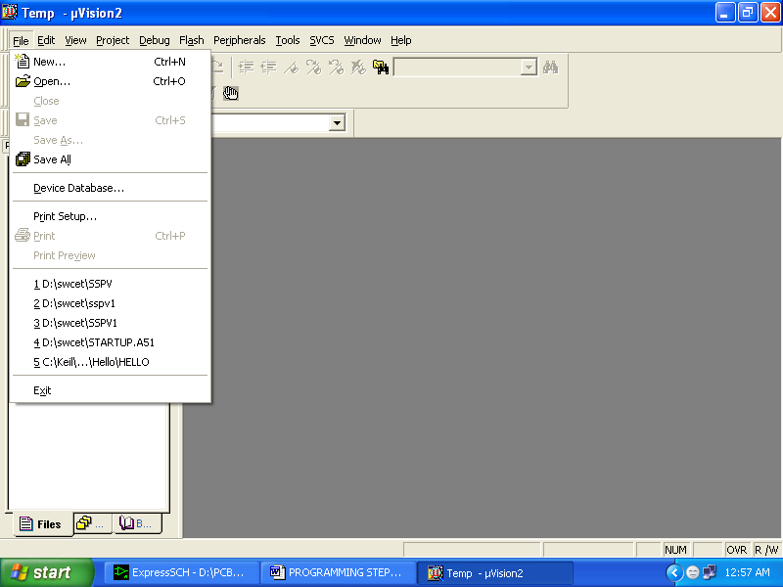
The next screen will be as shown in next page, and just maximize it by double clicking on its blue boarder.
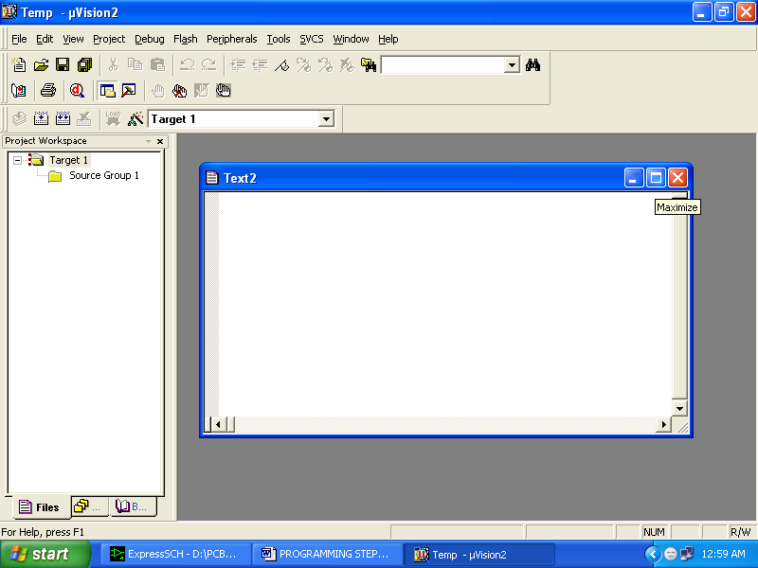

Now start writing program in either in “C” or “ASM”
For a program written in Assembly, then save it with extension “. asm” and for “C” based program save it with extension “ .C”

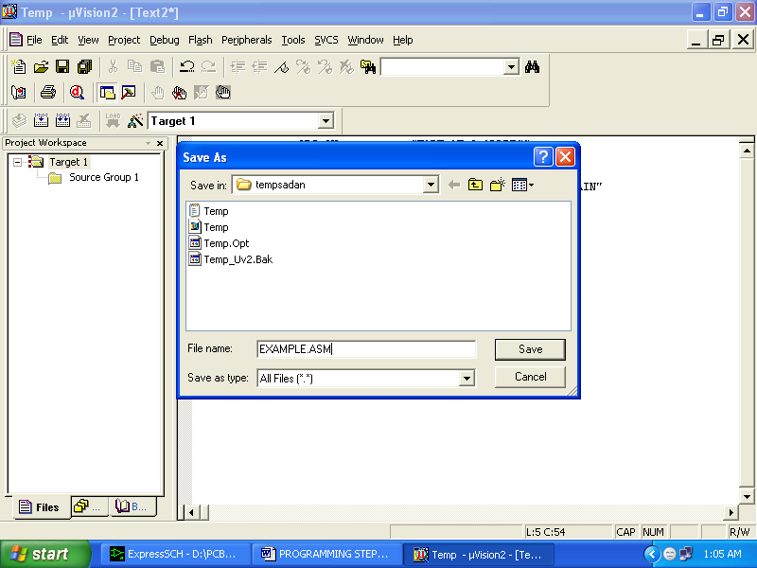

Now right click on Source group 1 and click on “Add files to Group Source”

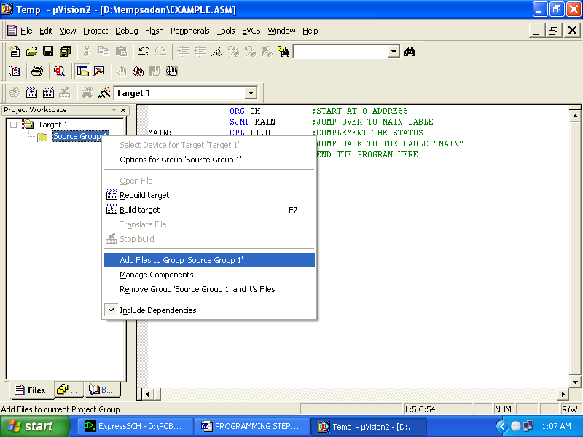
Now you will get another window, on which by default “C” files will appear.

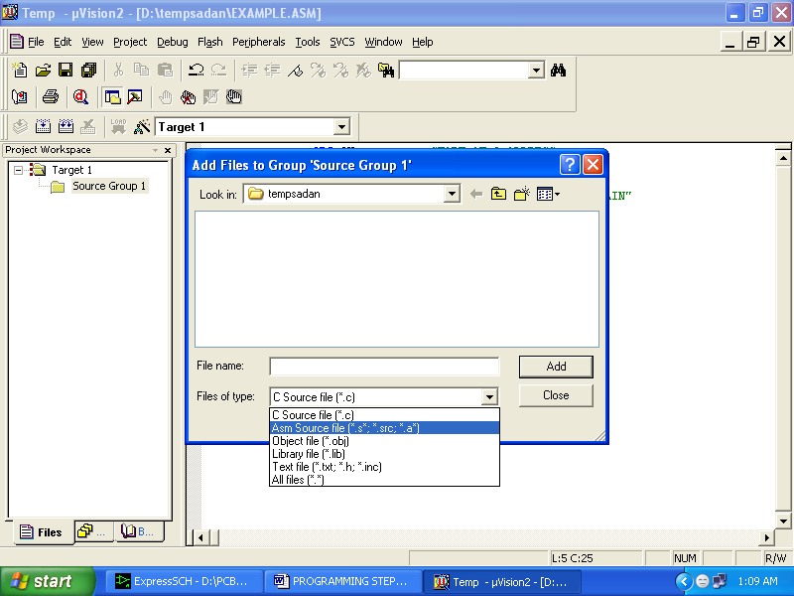

Now select as per your file extension given while saving the file
Click only one time on option “ADD”
Now Press function key F7 to compile. Any error will appear if so happen.
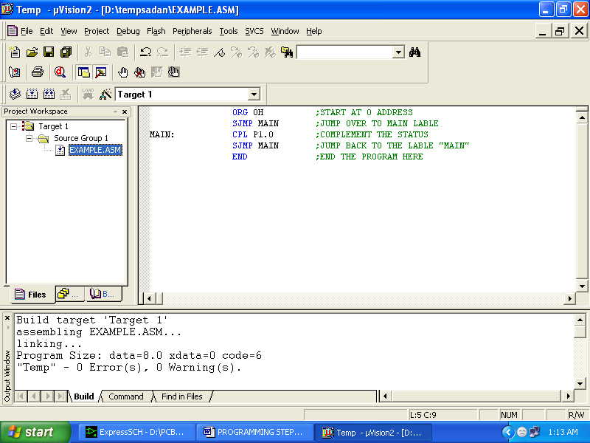

If the file contains no error, then press Control+F5 simultaneously.
The new window is as follows

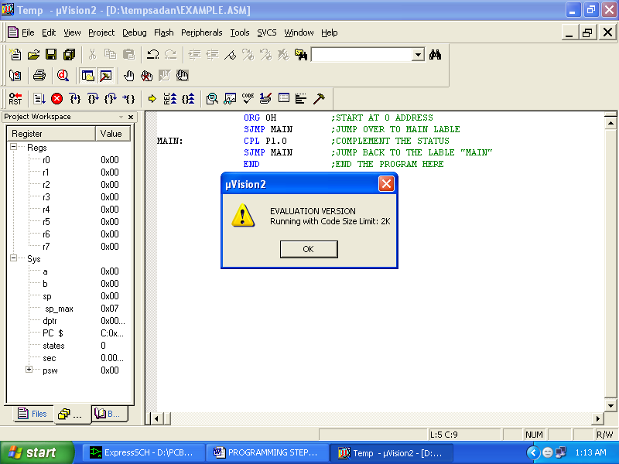

Then Click “OK”
Now Click on the Peripherals from menu bar, and check your required port as shown in fig below
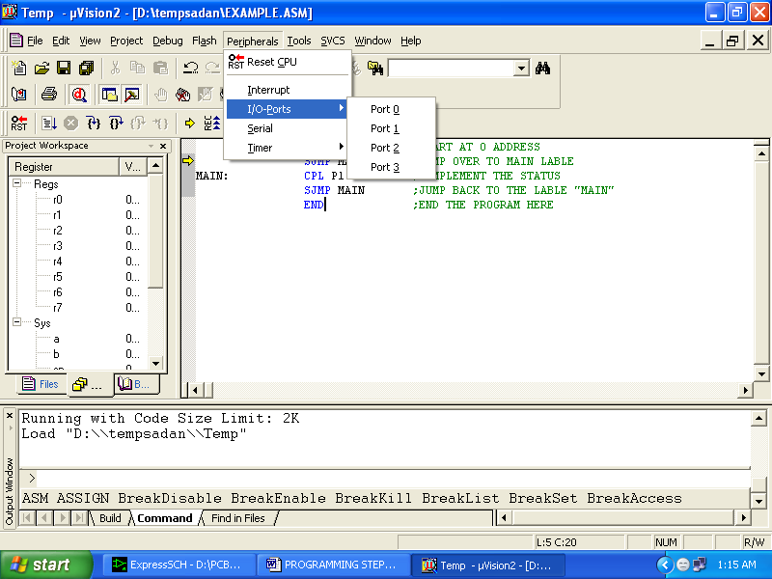

Drag the port a side and click in the program file.

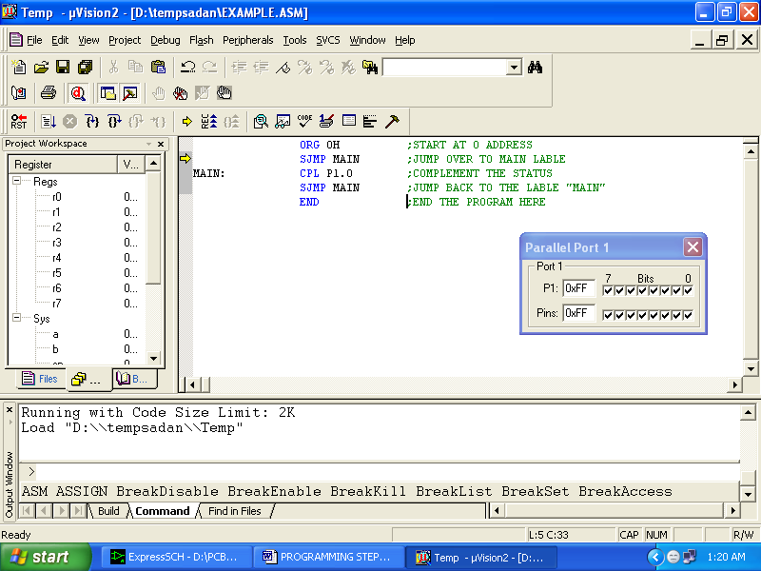

Now keep Pressing function key “F11” slowly and observe.
You are running your program successfully

CHAPTER- VI
PROTEUS DESIGN

6.1 Proteus Introduction
The aim of this tutorial is to take you through the process of entering a circuit of modest complexity in order to familiarize you with the techniques required to drive the schematic capture module in Proteus. The tutorial starts with the easiest topics such as placing and wiring up components, and then moves on to make use of the more sophisticated editing facilities, such as creating new library parts.
An accompanying tutorial in the PCB module then continues the project development using the completed schematic drawn in this tutorial.

6.2 Creating a New Project
We shall assume at this point that you have installed the Proteus 8 software package.
To start the software, click on the Start button and select Programs, Proteus 8 Professional and then the Proteus 8 application. The main application will then load and run and you will be presented with the Proteus home page.
If you have a Demonstration copy of the software you can start the Proteus application via the Proteus 8 Demonstration tab from the Start Menu.
In order to create a schematic, we must first create a project. Since this tutorial is partnered with the PCB tutorial, we will create a project for schematic/PCB.
Start by pressing the new project button near the top of the home page in Proteus.


On the first page of the Wizards specify a name and path for the project.
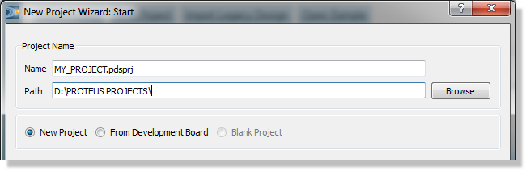
We need a schematic so check the box at the top of the next step and then choose the default template
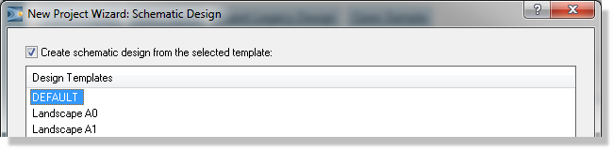
Similarly, we need a layout so check the box at the top of the layout page and again choose the default template.
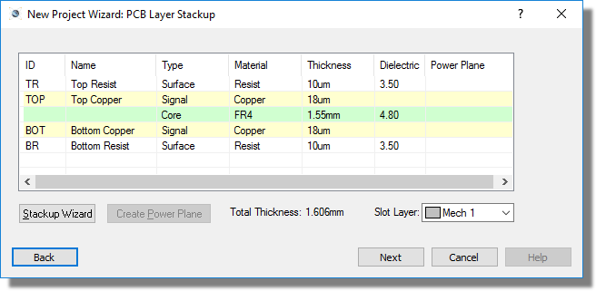
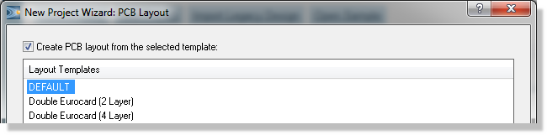
The next screen allows us to define the layer stack for our PCB. Since we will be designing a simple two layer board there is no configuration necessary here.
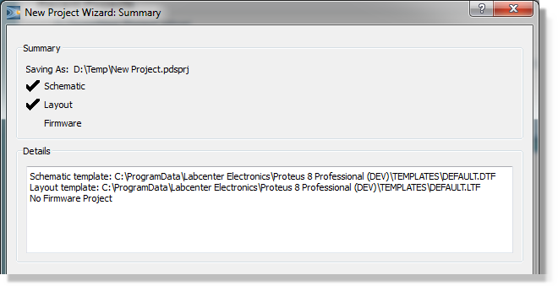
Click on the finish button to create the project.
A schematic template can contain sheet size, colour scheme, company logo, header block and various other aesthetic presets. Further information can be found in the Templates chapter of the reference manual.
A PCB template can contain board edge, mounting holes, design rules, layer stack and various other technology information. Refer to the Templates chapter in the PCB documentation for more information.
The configuration of the Layer Stack and Drill Spans is really important for multi-layer PCB's and is discussed in some detail in the reference manual.
The project will open with two tabs, one schematic capture and the other for PCB layout. Click on the schematic tab to bring the Schematic module to the foreground.
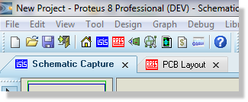

Toolbars and menu options will switch according to which tab is active (at the front).
Throughout this tutorial when we refer to an icon or a menu command we are assuming that the schematic tab is active.
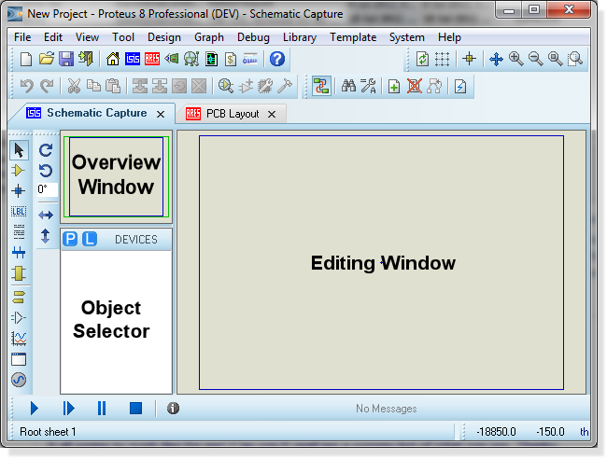
Right clicking the mouse either in the Object Selector or in the Overview Window will provide a context menu, including the option to ‘auto hide’ the left hand pane. This is extremely useful if you want to maximize the editing area of the application. When enabled the Object Selector and Overview Window will be minimized to a ‘flyout bar’ at the left (or right) of the application by default and will appear either when the mouse is placed over the bar or when the mode of operation is changed by selecting a different icon.
Proteus is designed to be as user friendly as possible and provides two main ways to help you see what is happening during the design process – objects are encircled with a dashed line or ‘twitched’ when the mouse is over them and mouse cursors will change according to function
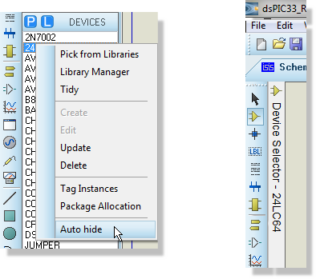
Visual Aids to Design
. Essentially, the object-twitching scheme tells you which object the mouse is over (the ‘hot’ object) and the mouse cursor tells you what will happen when you left click the mouse on that object. While extremely intuitive, a summary of cursors used, together with their actions, is provided below:

6.3 Cursor Description
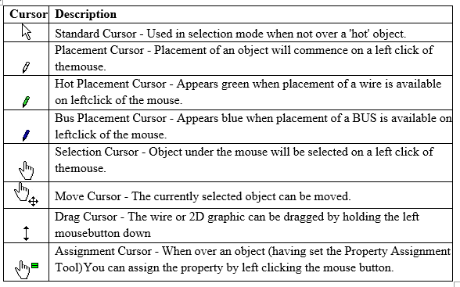
Keyboard Shortcuts
For those customers who prefer to invoke commands and dialogues via the keyboard Proteus provides a comprehensive and flexible scheme for assigning shortcuts. The dialogue form is invoked from the System Menu – Set Keyboard Mapping command, where all commands and operation modes can be accessed from the combo box at the top. Simply select the command you want, apply a key sequence and assign it to that command

6.4 Design Overview
The circuit we are going to draw is shown below. This is reasonably straightforward schematic that will nonetheless allow us to cover most of the major features of the Proteus schematic capture package. Being a real-world design, it will also allow users to follow the design through the PCB phase of development via the PCB tutorial.
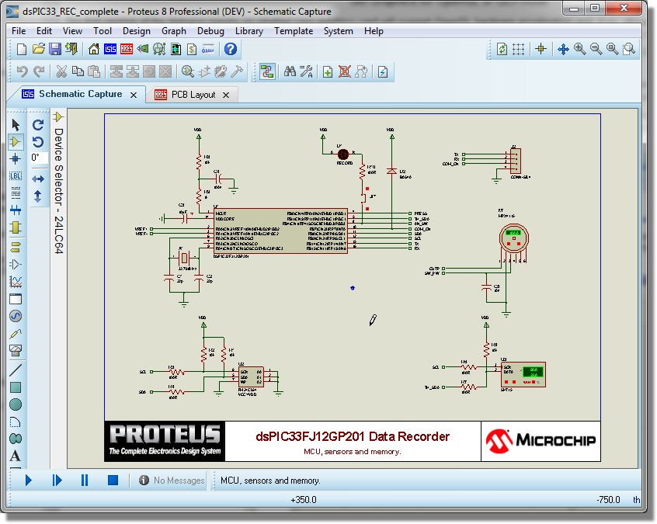

6.5 Selecting Parts from the Library
You can select parts from the library in one of two ways:
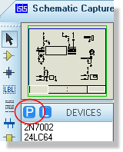
Click on the P button at the top left of the Object Selector as shown below. You can also use the Browse Library icon on the keyboard shortcut for this command (by default this is the P key on the keyboard).

Right click the mouse on an empty area of the schematic and select Place – Component - From Libraries from the resulting context menu as shown below:
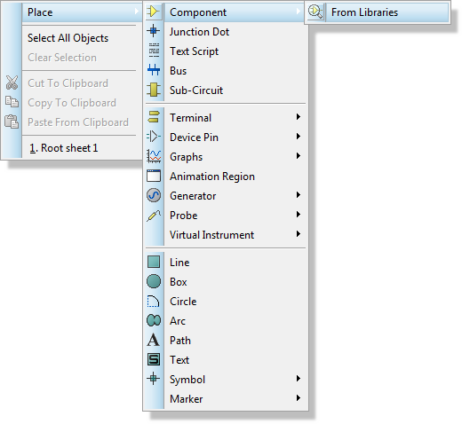
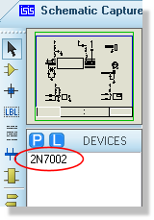
The 2N7002 in the Object Selector
Given that we know the names of all the parts we want we could simply proceed by using this technique to bring in all the components we need. However, this may not always be the case and Proteus provides several methods for finding parts in the component libraries. One of the most intuitive is to use the library browser a little like an internet search engine, typing in descriptive keywords and then browsing the results to find a specific part. Try this now with the resistors, typing in ‘1k resistor’ in the keywords field of the library browser dialogue to locate the CHIPRES1K component (double click on the part in the results list to import into the schematic). We could similarly search for ‘10k SMT resistor’ to find and insert the CHIPRES10k component and so on.
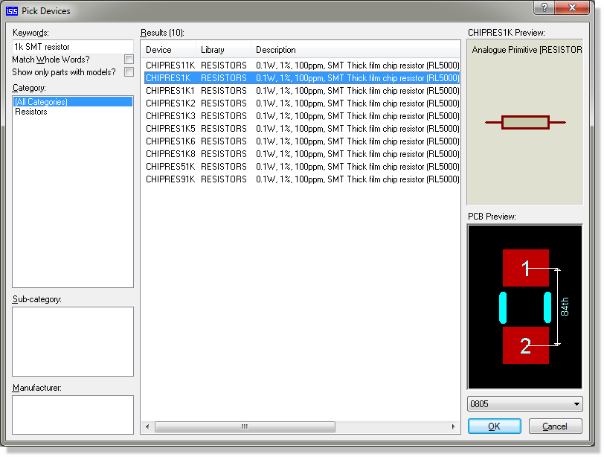
Picking a CHIPRES1K Resistor from the Pick Devices form
Note that there are web search results accessible by clicking on the yellow bar at the bottom of the search display. This provides free access (you need to register a free account) to over 15 million library parts, meaning that if the part is not included with the installed libraries you can still source it from this dialogue form.
Placing Objects on the Schematic
Having selected the parts we need the next thing is to actually place them on the drawing area
– the Editing Window – and wire them together. You’ll notice from the screenshot that we have also split the contents of the schematic into logical blocks of circuitry. This is partly aesthetic but also reduces wiring clutter on the schematic and will allow us to cover the use of terminals to form connections as we work through the tutorial.

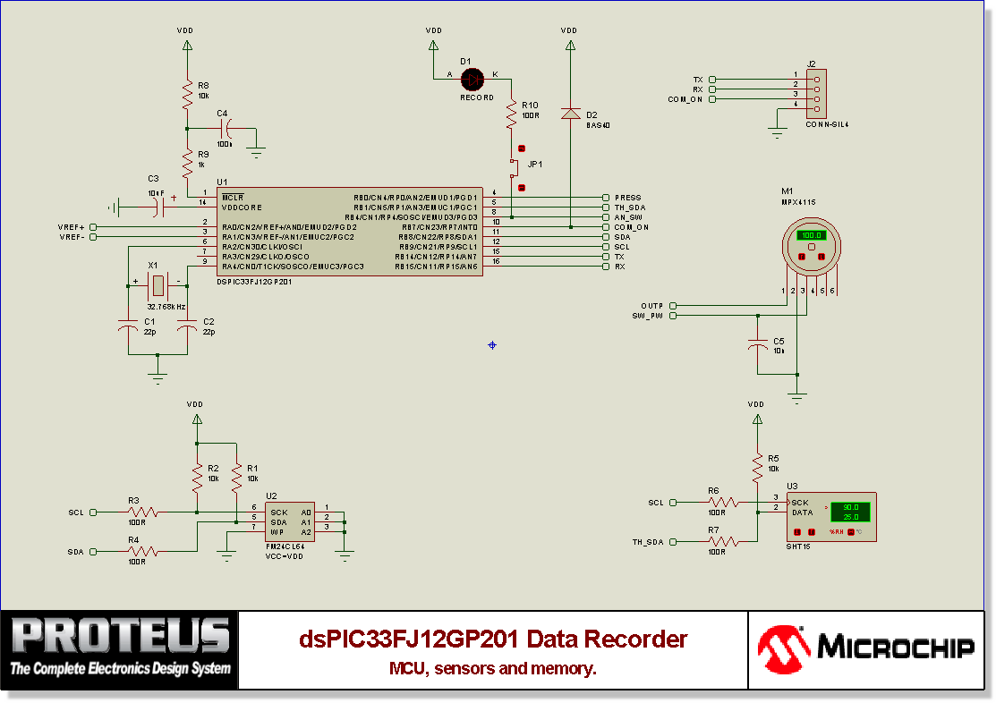

6.6 Part Labels and Annotation
You should see that all the parts you have placed have both a unique reference and a value. A unique and sequential annotation is assigned to components as you place them on the schematic, although you can re-annotate manually if you need to.
You have full control over the position and visibility of part labels – you can change the values, move the position or hide information that you feel is unnecessary. The discussion below details how to manipulate part labels on a per component basis.
If you zoom in on any resistor you have placed you will see that Proteus has labelled it with a unique Reference (e.g. ‘R1) and also with a Value (e.g. ‘10k’). You can edit both these fields and their visibility via the Edit Component dialogue form. Launch this dialogue form now by double clicking the left mouse button over the resistor (or using one of the alternative methods discussed previously).

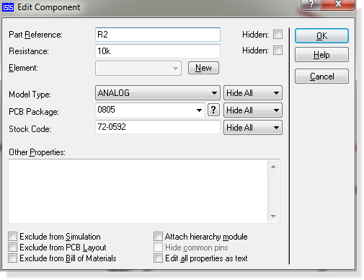

CHAPTER- VII
CONCLUSION

Project Conclusion: B-3 Sensor-Based Street Light System

In conclusion, the B-3 Sensor-Based Street Light System has proven to be an effective and innovative solution for improving energy efficiency, reducing operational costs, and enhancing public safety in urban areas. The integration of B-3 sensors allows for real-time adjustments in lighting based on environmental factors such as ambient light and motion detection. This ensures that the street lights operate at optimal brightness levels, providing sufficient illumination when needed and conserving energy during periods of inactivity.

The successful implementation of this system highlights its potential for long-term sustainability, with reduced energy consumption, lower maintenance costs, and a reduced environmental footprint. The project's design demonstrates how smart technology can be used to address urban lighting challenges, offering a more eco-friendly and cost-effective alternative to traditional street lighting systems.

Moreover, this sensor-based street lighting solution aligns with modern urban development trends, where smart infrastructure plays a crucial role in enhancing city living standards. Moving forward, the scalability of this system suggests that it can be expanded and adapted to various regions, ultimately contributing to smarter, more sustainable cities globally.

